The Woldt’s of Egg Harbor and West Jacksonport (1881 – 2012)
By: Rich Woldt (4/21/45): Son of Roland August Ernst “Fritz” Woldt (1916 – 1974) (Corrine Schneider-Woldt-Vieth daughter of Emil and Christina Schnieder), Grandson of August “Dick” Woldt (1887 – 1959) (Anna Herbst-Woldt-Hemble), and Great Grandson of August Woldt (1852 – 1925) and Bertha Pulzine (1850 – 1921) who immigrated to Egg Harbor in 1881 from Pomerania, Germany bringing Emma their infant daughter and five year old Otto.
That’s me in the tub and my wife Emily (Fisher) on the rim in ’84 before we got indoor plumbing. Next is my father “Fritz Woldt” with the “boom-boom” he was known to play at local bars and in parades. That picture was taken August 17, 1974 the day he died from a massive heart after playing in Fish Creek’s Fireman’s Day Parade. Next is Grandpa “Dick” Woldt. His name was August but they called him “Dick” which was the name given the “enforcer” in the logging camps of northern Wisconsin. The white bearded man in the picture on the far right is great-great-grandpa August Woldt. August is holding his granddaughter’s hand; Virginia (Woldt) Weisgerber daughter of Herman and Hilda Woldt. That picture was taken about in 1918 next to a big white barn that use to be behind Herman Woldt’s bar in downtown Egg Harbor. August died in a bedroom above Herman’s bar in 1925.The current owners of Ma-Ma Roses have said the white bearded spirit of August Woldt still walks the floors opening and shutting doors late at night.
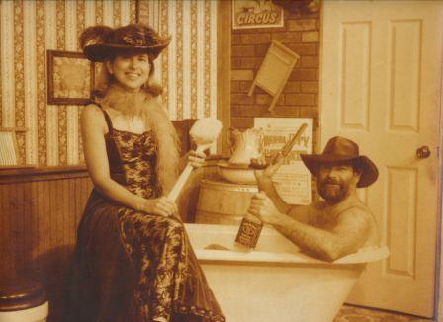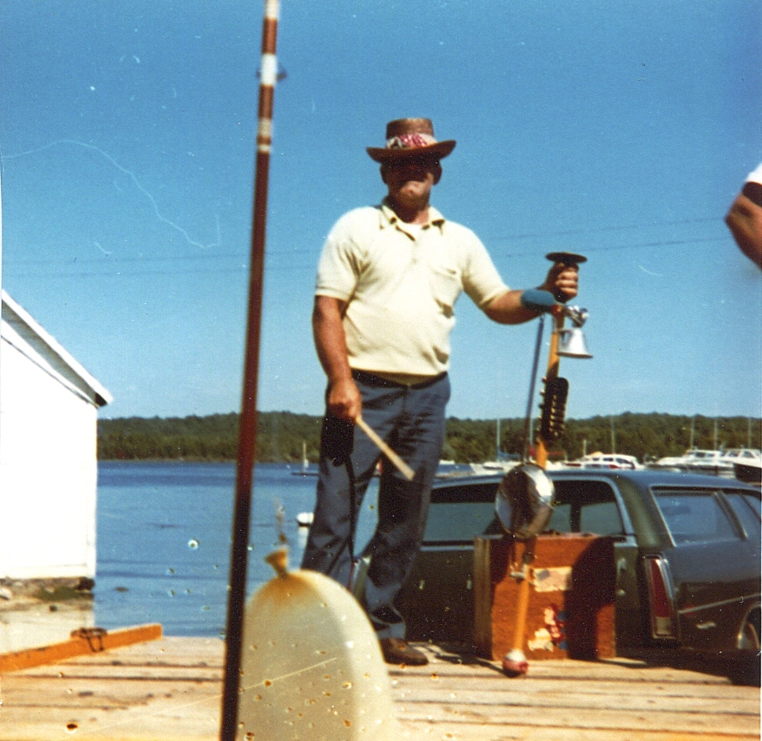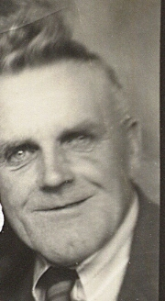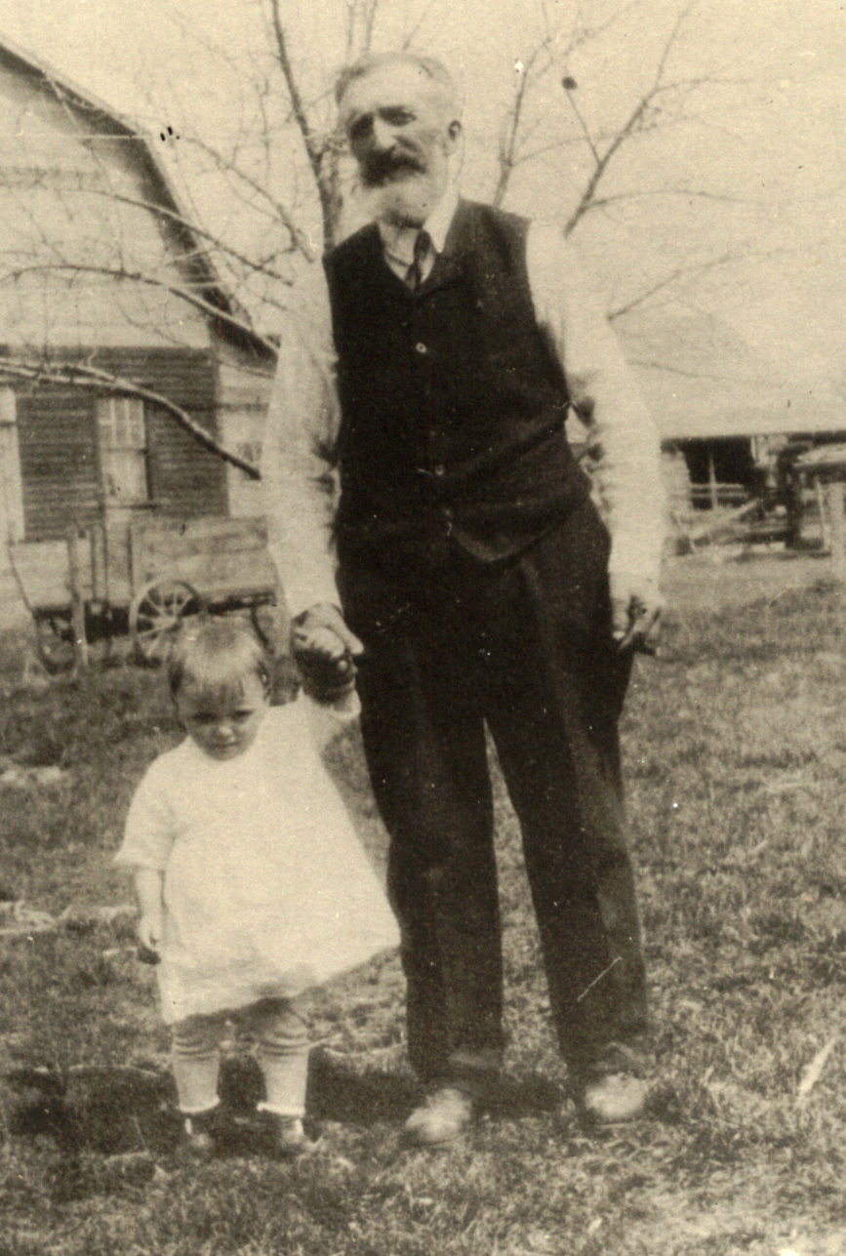
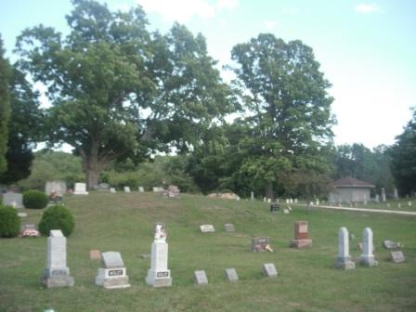  Note: Dad is on top the hill near his ole friend Chief Tschekatch’Ake’Mau III (Chief Roy Oskosh). Aunt Myrtle is in the northeast corner.  Many Woldt’ head stones were made from Door County lime stone!  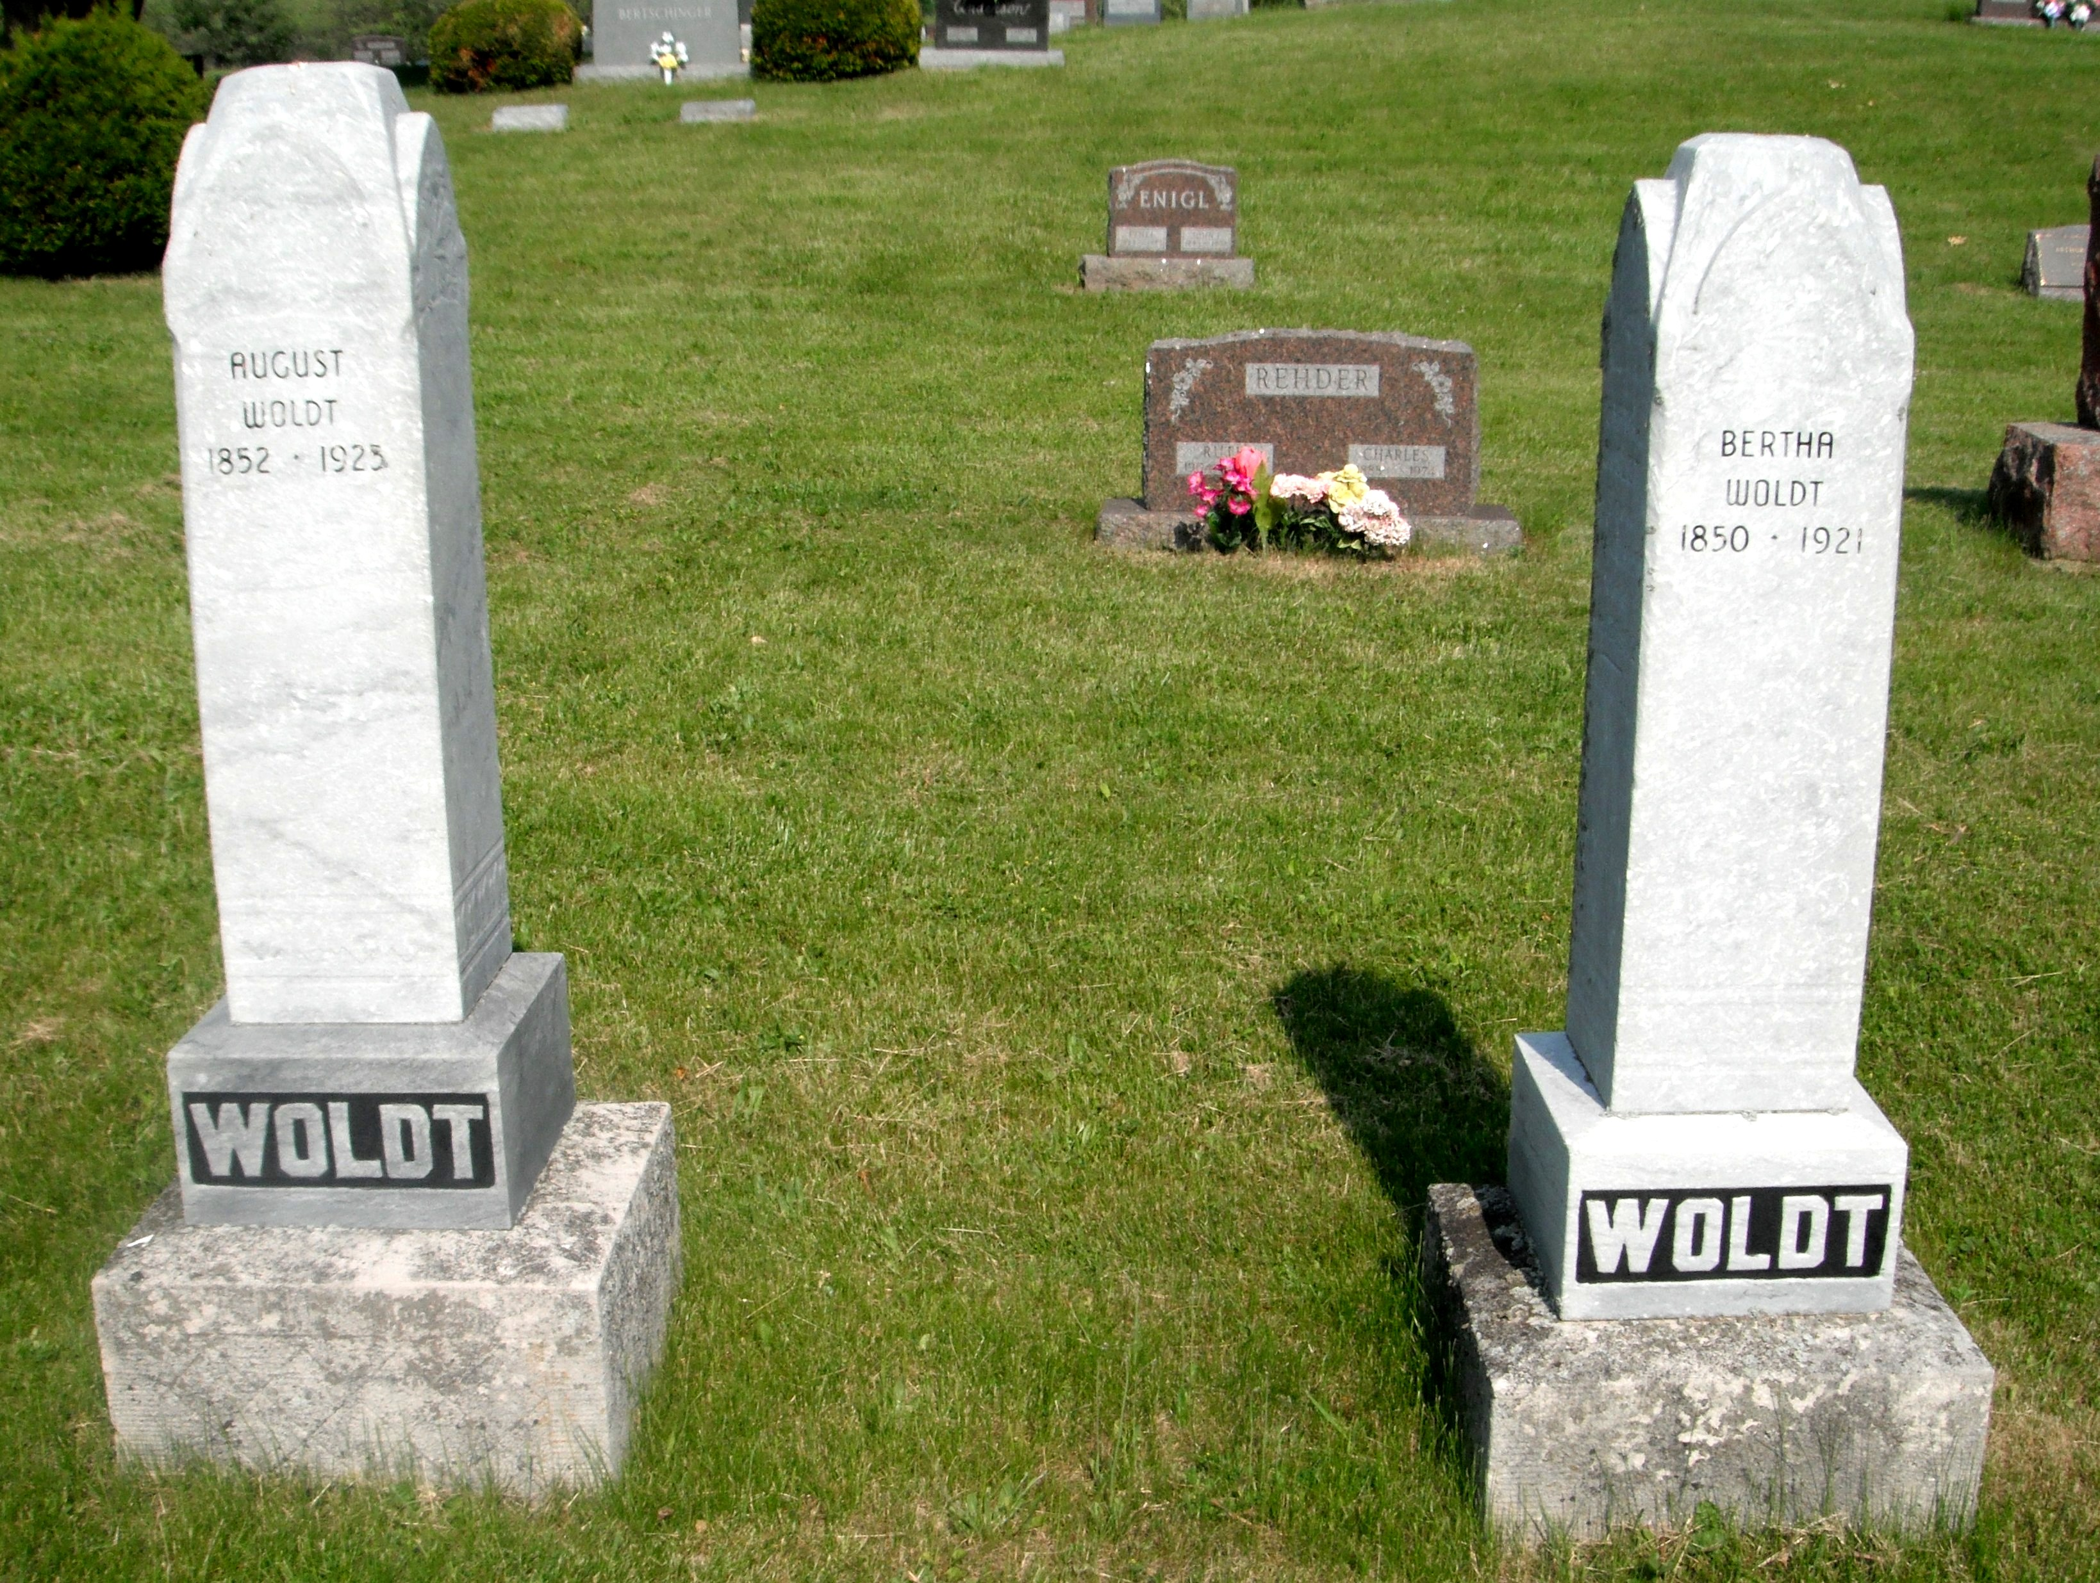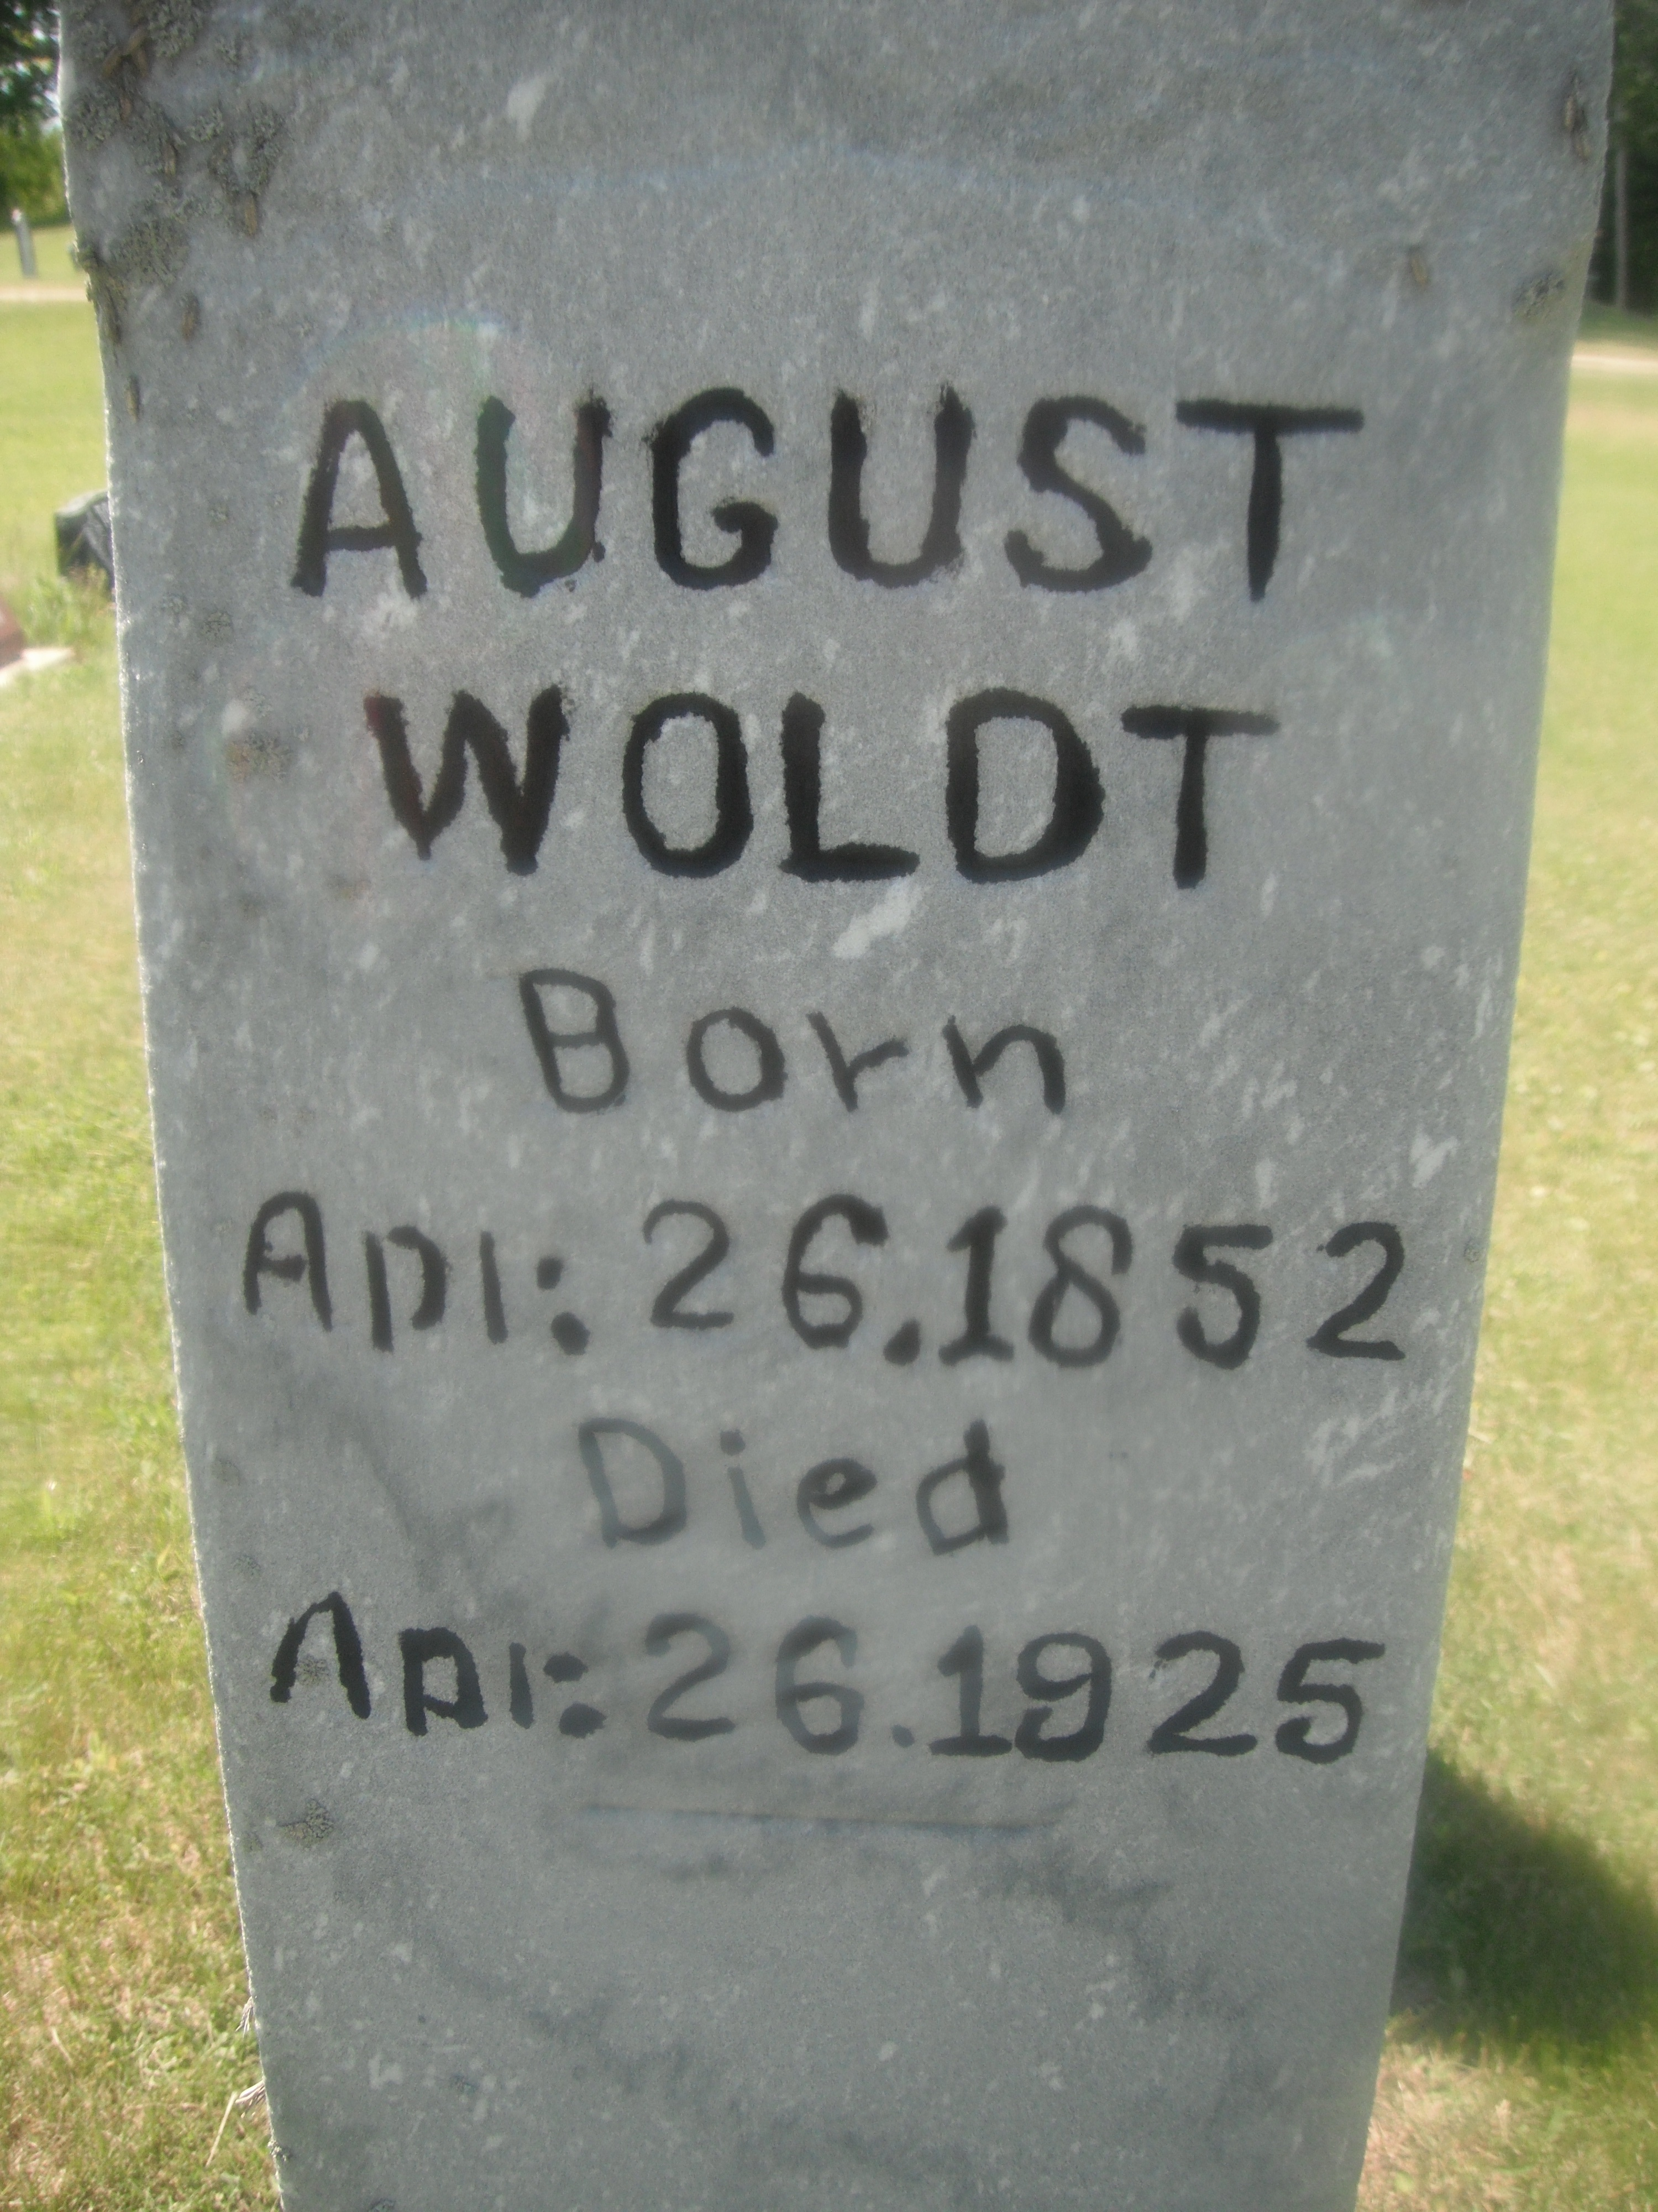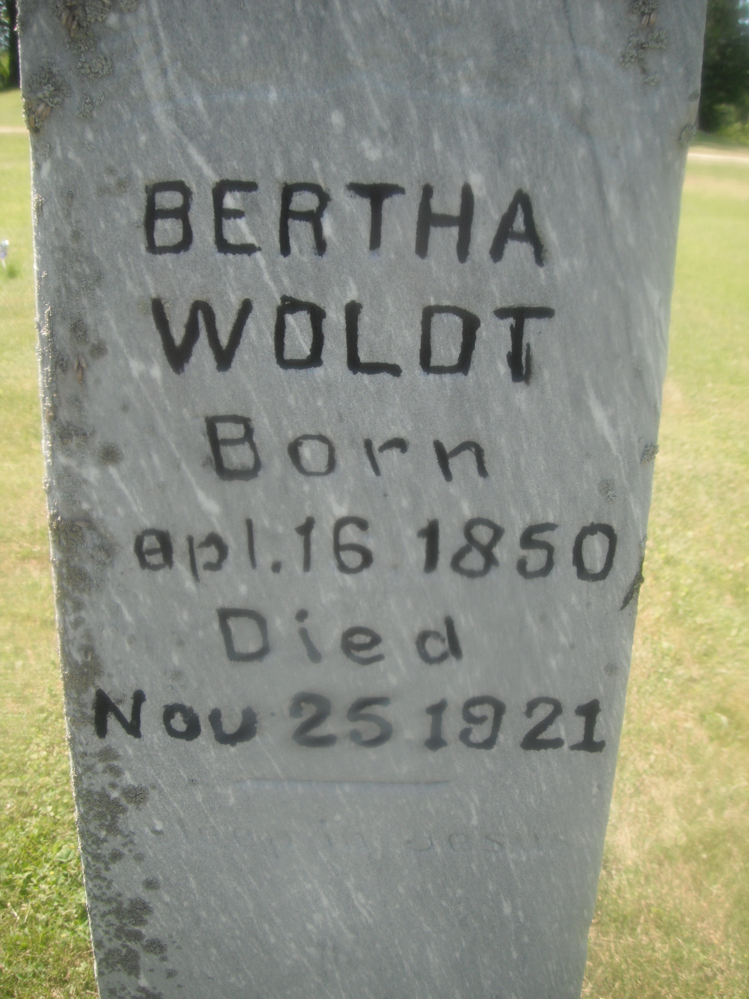  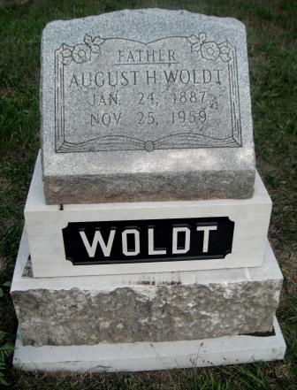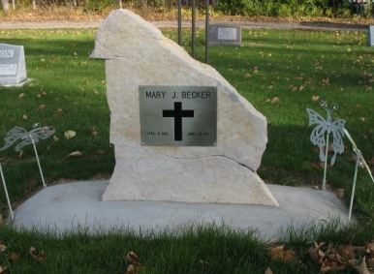  Left: August “Dick” Woldt  Right: In Bailey’s Harbor cemetery with all our Becker relatives is Mary Becker wife of cousin Bill, son of Clara the daughter of grandpa “Dick” and sister of “Fritz” Woldt. Got it? | Egg Harbor Cemetery  Most of my Woldt’ relatives who landed in Egg Harbor in1881have passed away and are buried either in our Egg Harbor cemetery or in the Lutheran Cemetery due east near West Jacksonport.  Roland “Fritz” Woldt is on the hill.  August and Bertha Woldt are near the road as is,  Grandpa: August “Dick” Woldt and,  Charles Woldt: Son of August and Bertha Woldt.  The head stone for Roy “Decker” Woldt and wife Eloise has been placed there as a marker only. Decker is still playing golf and ball in Texas.  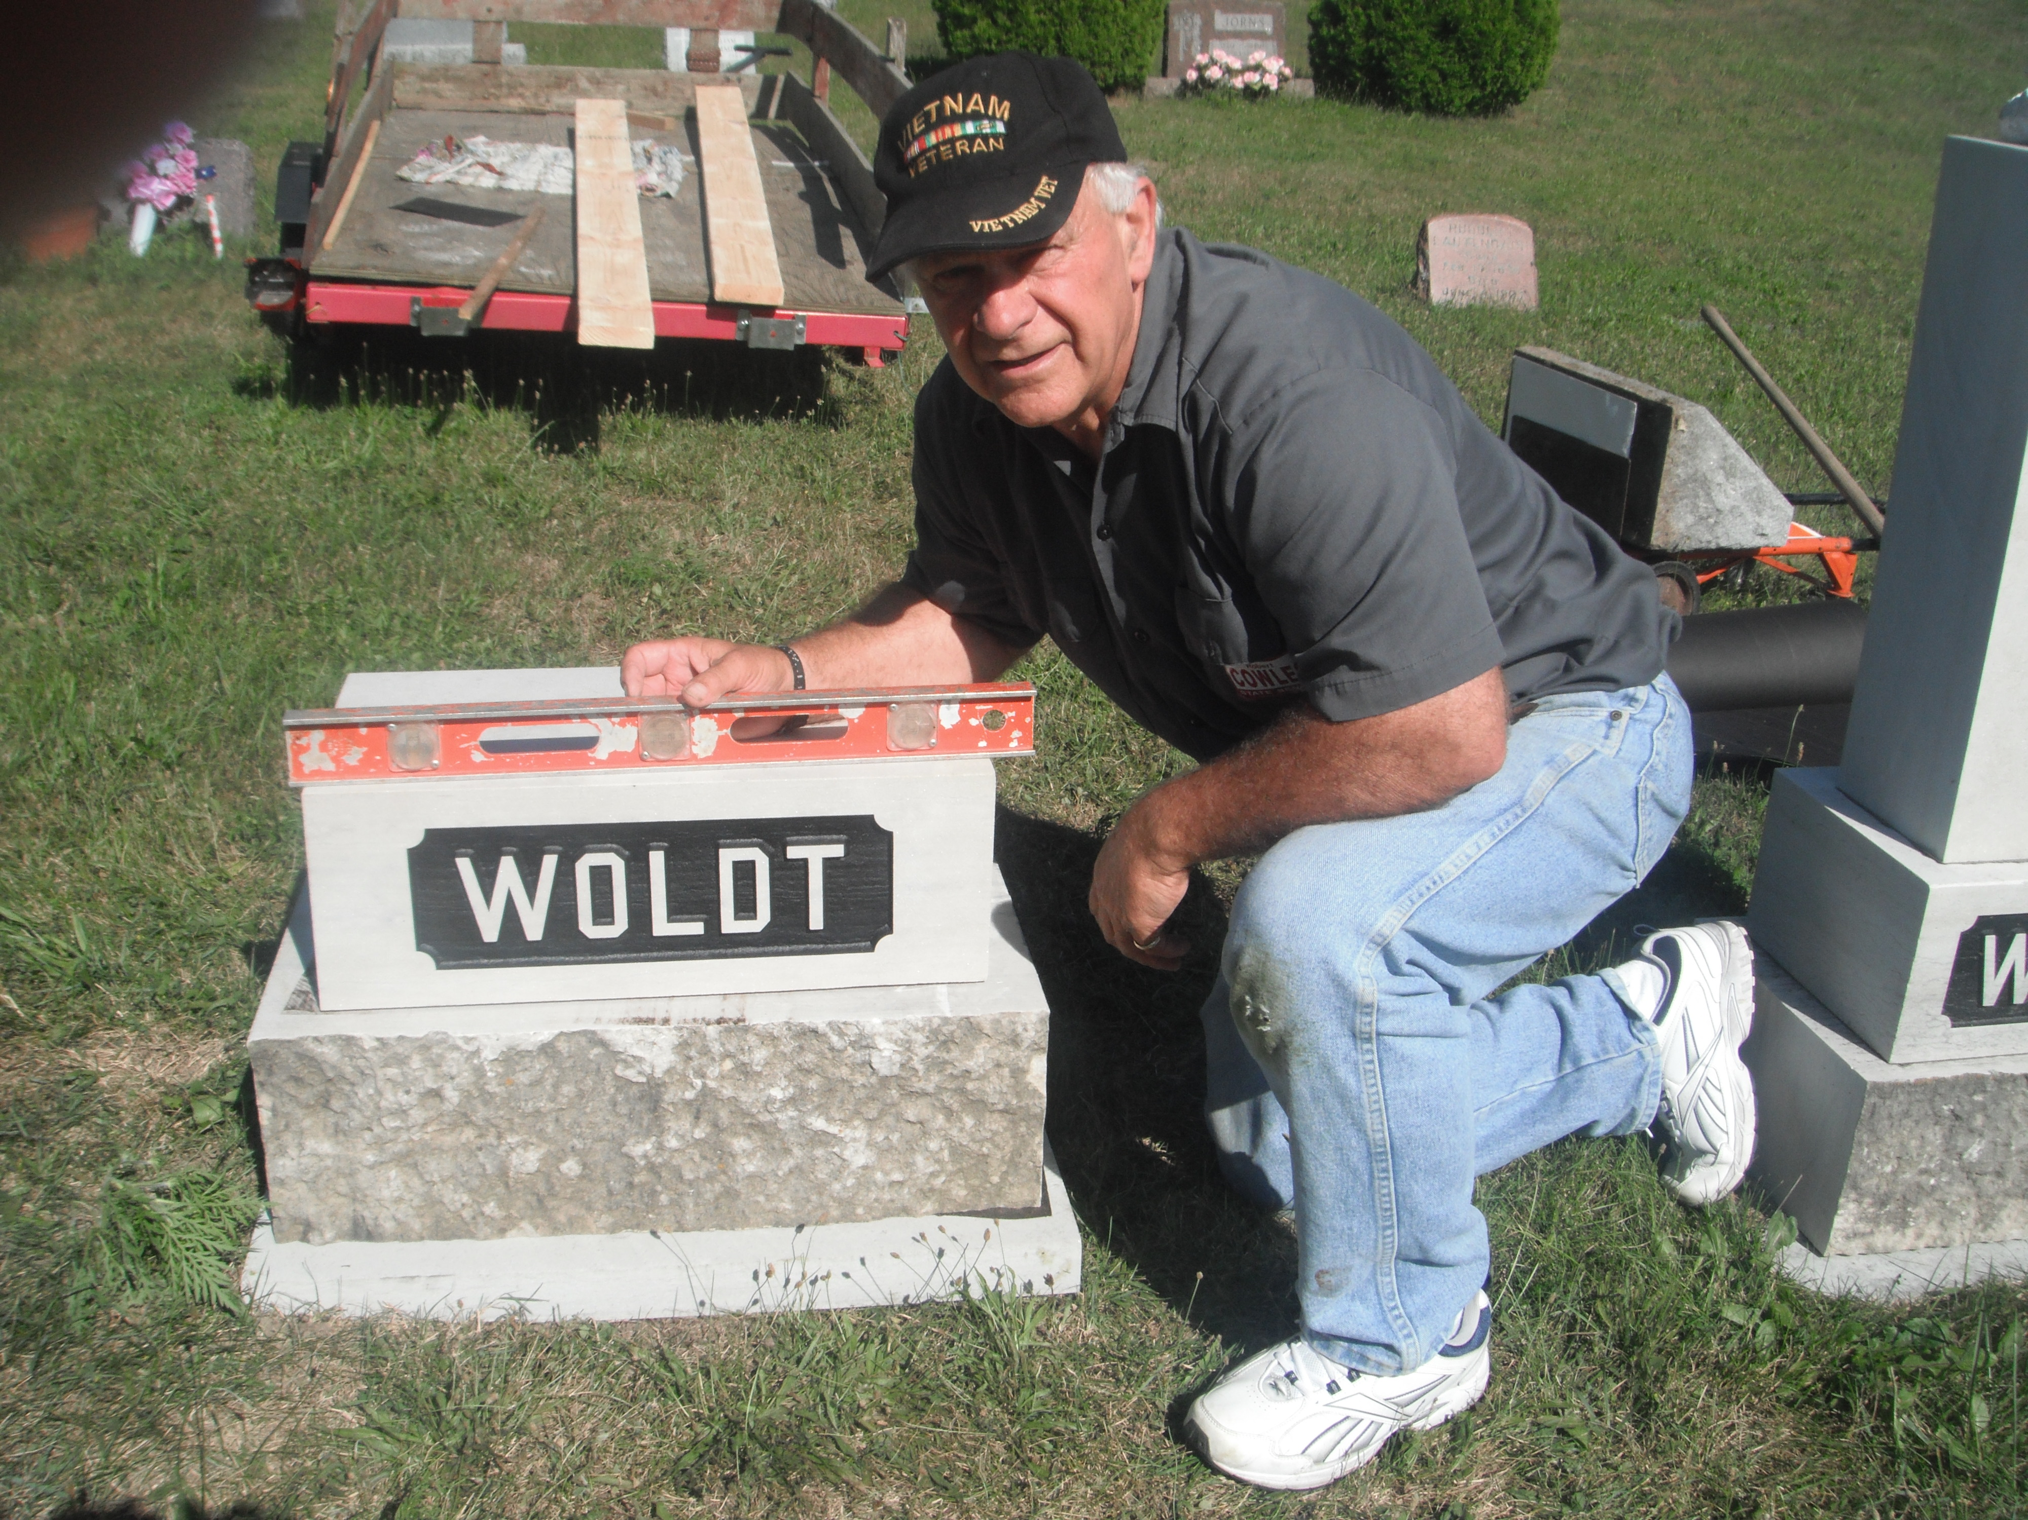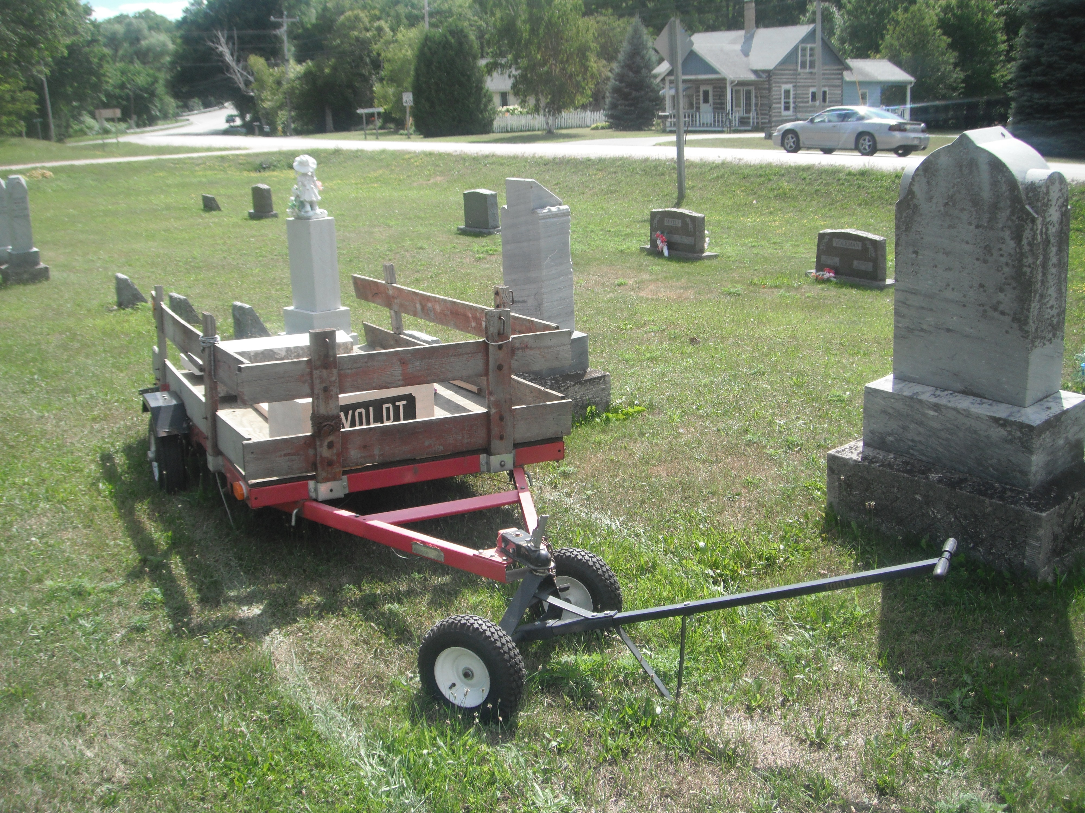  FYI: Many stones were quarried in Door County. I quarried grandpa Dick’s and Decker’s stone from Emily’s fathers’ quarry south of Sturgeon Bay.  August, Bertha, Emma, and Otto were all naturalized citizens of the U.S. in 1885. According to the birth certificate for Charles Woldt (1879 – 1930) he was born in Egg Harbor to Bertha “Pulcen” father not known. I think Charles is Carl because Karl in German was often called “Charles” in English.  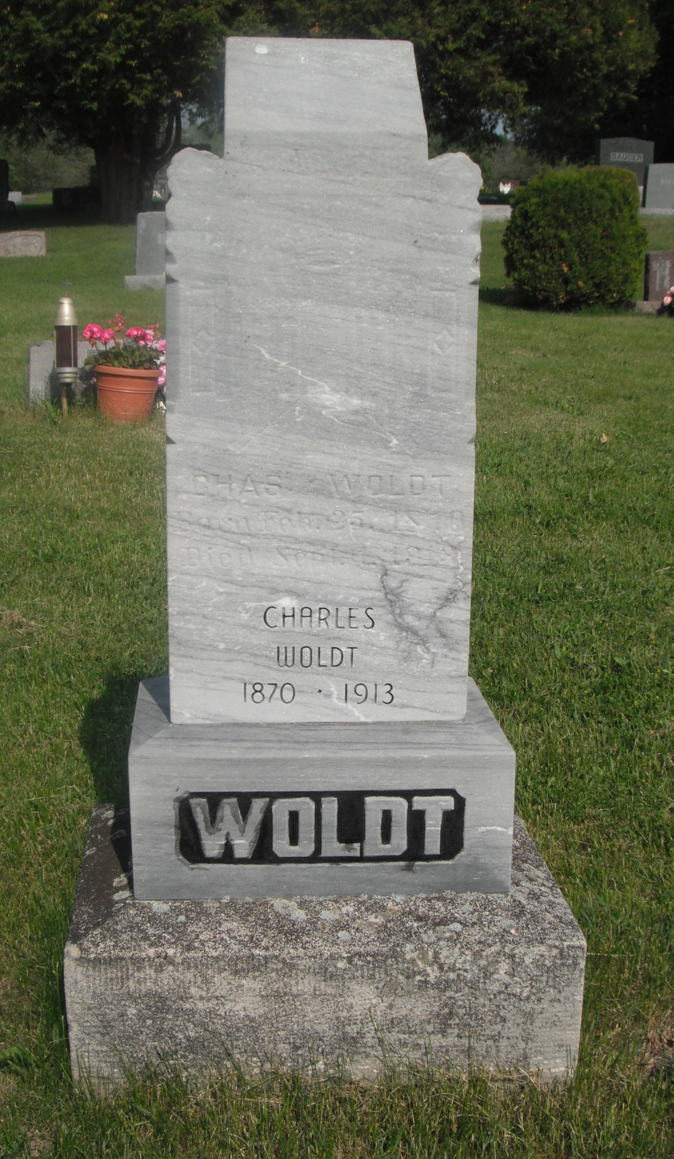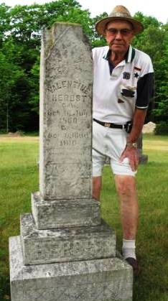  Most Door County Woldt’s are descendants of Valentine Herbst father of Nicholas who married Minnie Lautenbach and had Anna who married “Dick” father of Fritz and Roy “Decker,” Clara Becker, and Myrtle Patza. Got it? That’s Decker in the picture above standing next to Valentine Herbst’s head stone in West Jacksonport.
FYI: Herman and Hilda along with Roger their son are all buried in St. Paul’s Lutheran Church cemetery in Juddville.
Thirteenth Census of the United States: 1910 Population
State of Wisconsin
County of Door
Township or Other Division of County: Egg Harbor Town
Enumeration District No 44 Wheet No 6
Enumerated on 22nd day of April 1910, Joseph Schneider Enumerator:
Number 13 dwelling # 54
Woldt, August Head MW 59 Married 39 yrs Ger. Fa: Ger. Mo: Ger. Naturalized 1885 Farmer Own Farm
Woldt, Bertha wife FW 60 M 39 yrs child 8/8 born-German Fa: Ger. Mo: Ger. Nat in 1885 no occup
Woldt, Herman son MW 26 Single born-Wisconsin Fa: Ger. Mo. Ger. Bar Keeper / Saloon
Woldt, Julius son MW 24 Single born-Wisconsin Fa: Ger. Mo: Ger Farmer / Home Farm
Woldt, August son MW 22 Single born-Wisconsin Fa: Ger. Mo: Ger. Farmer / Home Farm
Woldt, Emma daughter FW 28 Single born-Germany Fa: Ger. Mo: Ger. Naturalized 1885 no occupation
Woldt, Lydia daughter FW 19 Single born-Wisconsin Fa: Ger. Mo: Ger. working / hotel

Woldt’ family stories, tails, memories, and it appear a few down-right lies date back to October 22, 1881 when August (age 29), his wife Bertha (Pulzine, age 30), Bertha’s son Carl (age 9), Otto (age 6), and Emma (age 7 months) arrive at Castle Island aboard the “Leipzig” sailing from Breman, Germany (Prussia). Carl later is called “Charles” and according to his death certificate was born in Egg Harbor in 1870 to Bertha Polcen, father unknown. August, Bertha, Otto, and Emma became naturalized citizens of the U.S. in 1885. Maybe that’s why they said Carl i.e. Charles was born in Egg Harbor. Or maybe Bertha was in Egg Harbor in 1869, had Carl and then returned to German to find a husband? Charles death certificate indicates he died August 31, 1913 after living 40 years, 11 months, and 14 days.
They arrived in Egg Harbor by stagecoach after traveling across country via rail, stagecoach, wagons and on horseback. Soon after arriving they settled on wooded land one mile east of Egg Harbor which is now the Tank’ Farm at 4249 Maple Tree Road.
And so begins my story of the Woldt’ of Wisconsin!
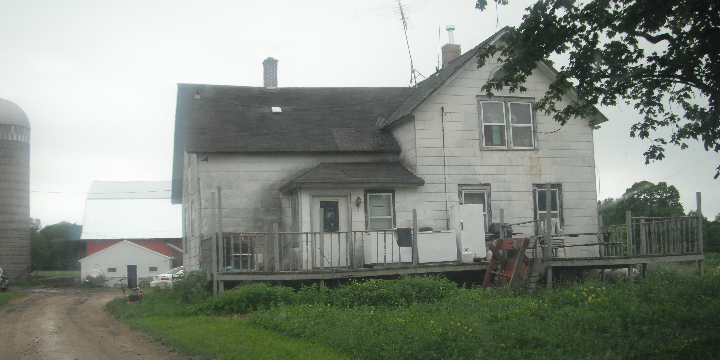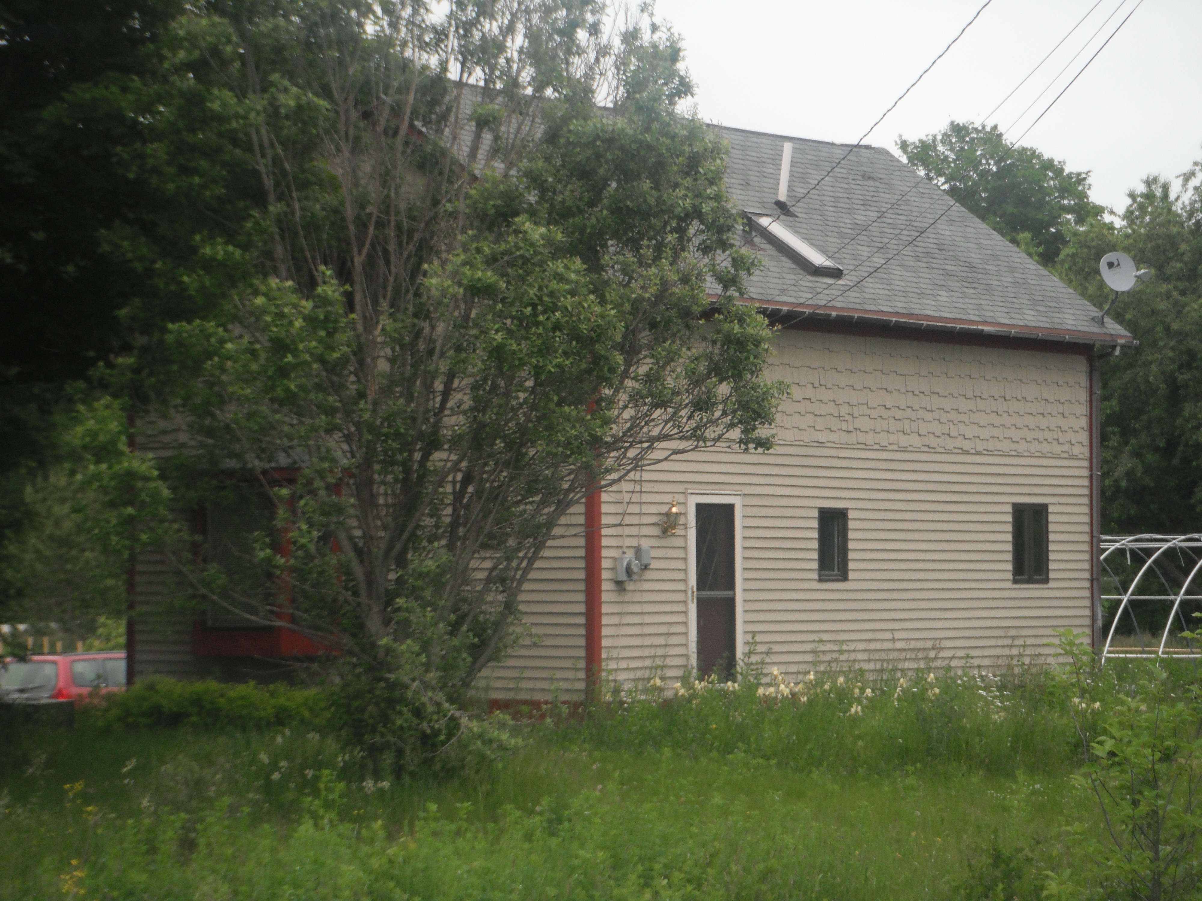

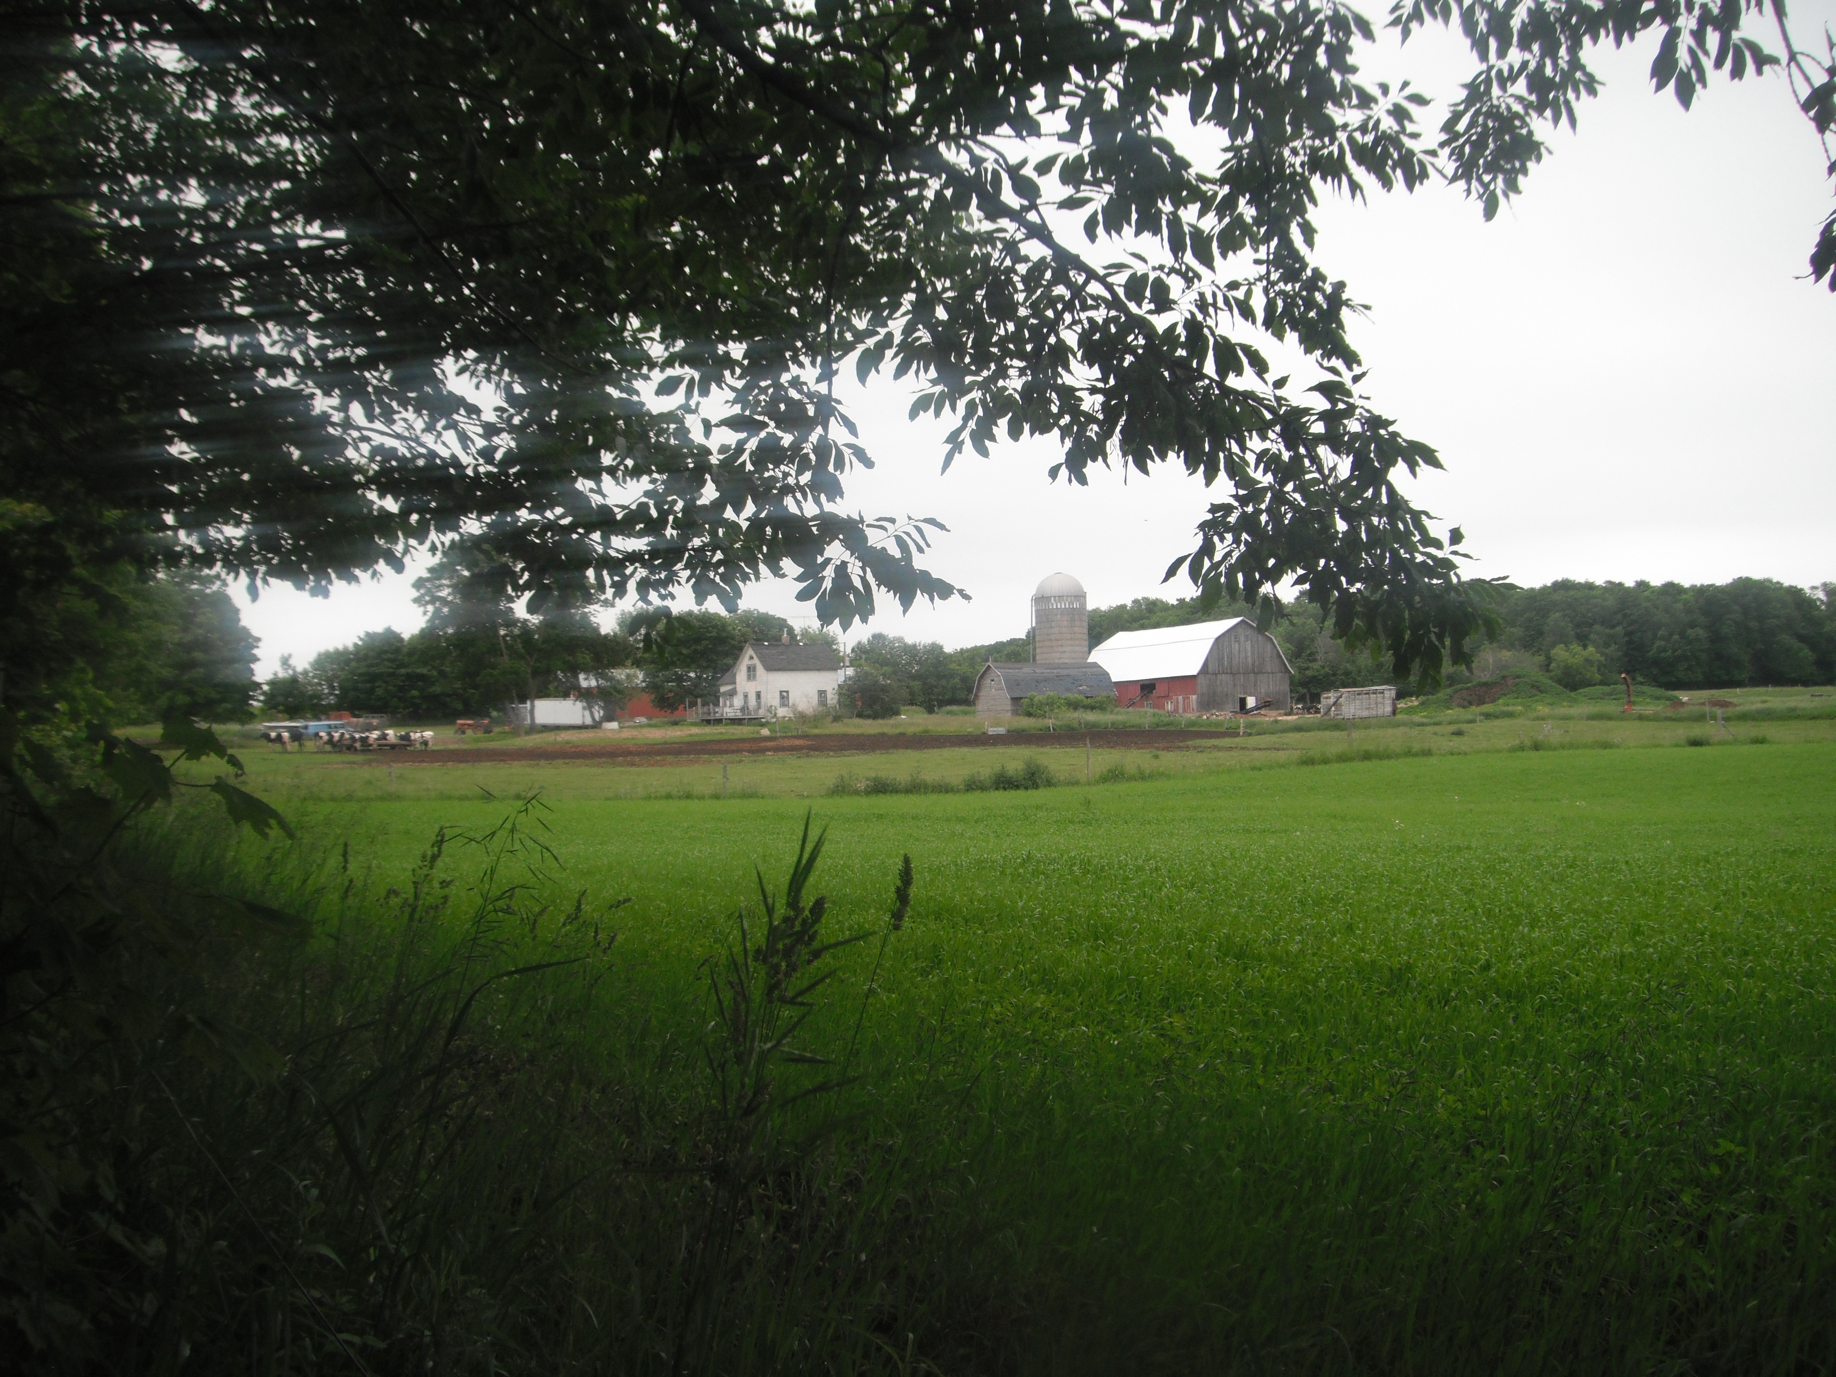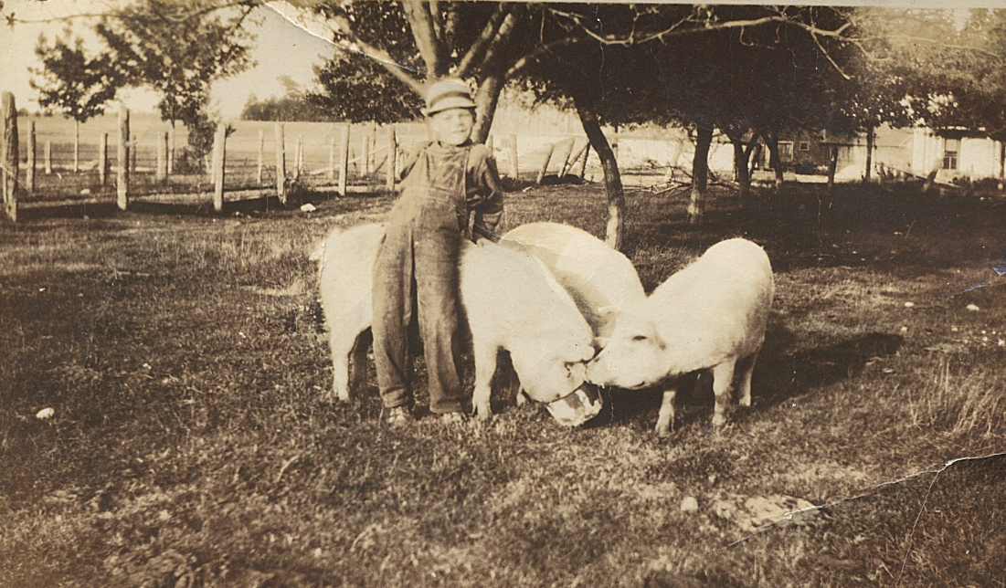
The Woldt’ farm was a busy place from sun-up to sun-down. Much time was spent clearing the land and planting crops to feed dairy cattle, horses, pigs, chickens, a mule and too many ornery goats. While everyone worked on the farm year around, the men worked in lumber camps in the winter while the women did chores, canned, and raised kids; the inevitable consequence of too long, too cold, and too boring winters in Egg Harbor.
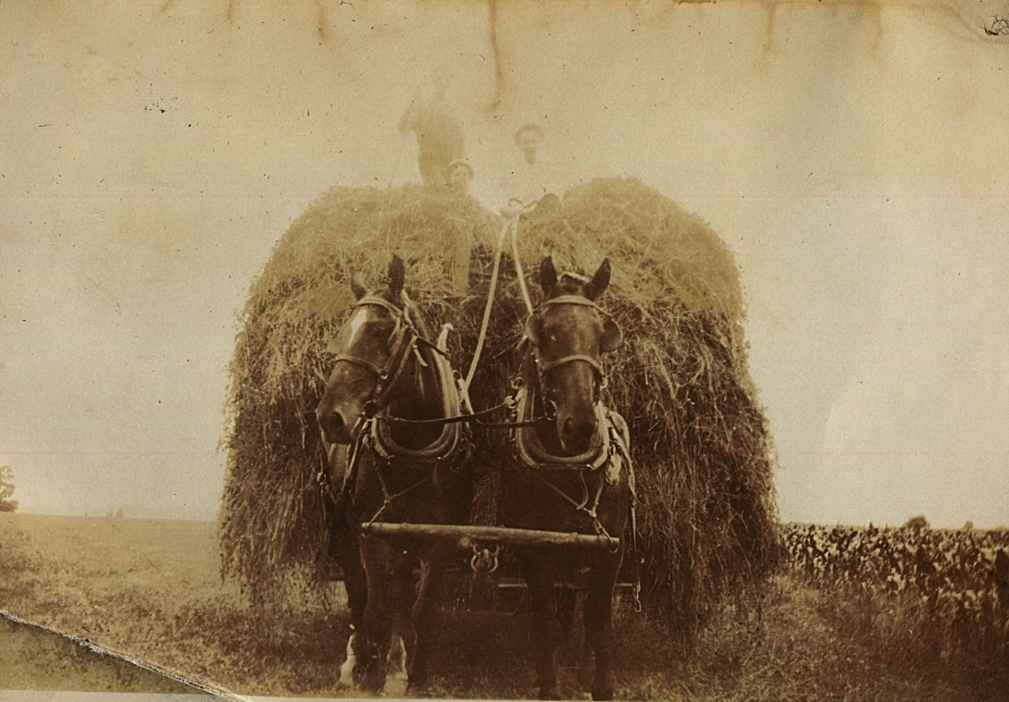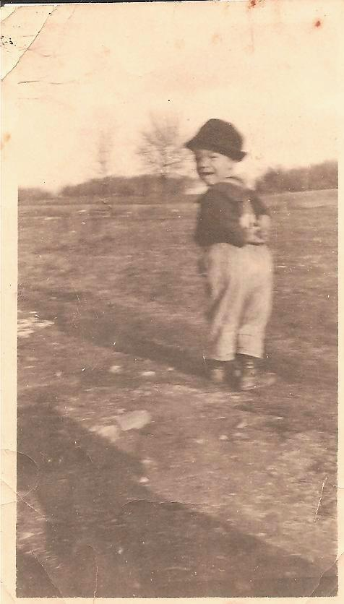
Herman was August and Bertha’s first son born in the U.S.A. He was born in Egg Harbor on the farm in 1883, Julius was their second in 1885, my grandfather August “Dick” Woldt on January 24, 1887, and Lidia (Nicholas “Doc” Schmidt) their only daughter born in Egg Harbor on the farm in 1891.
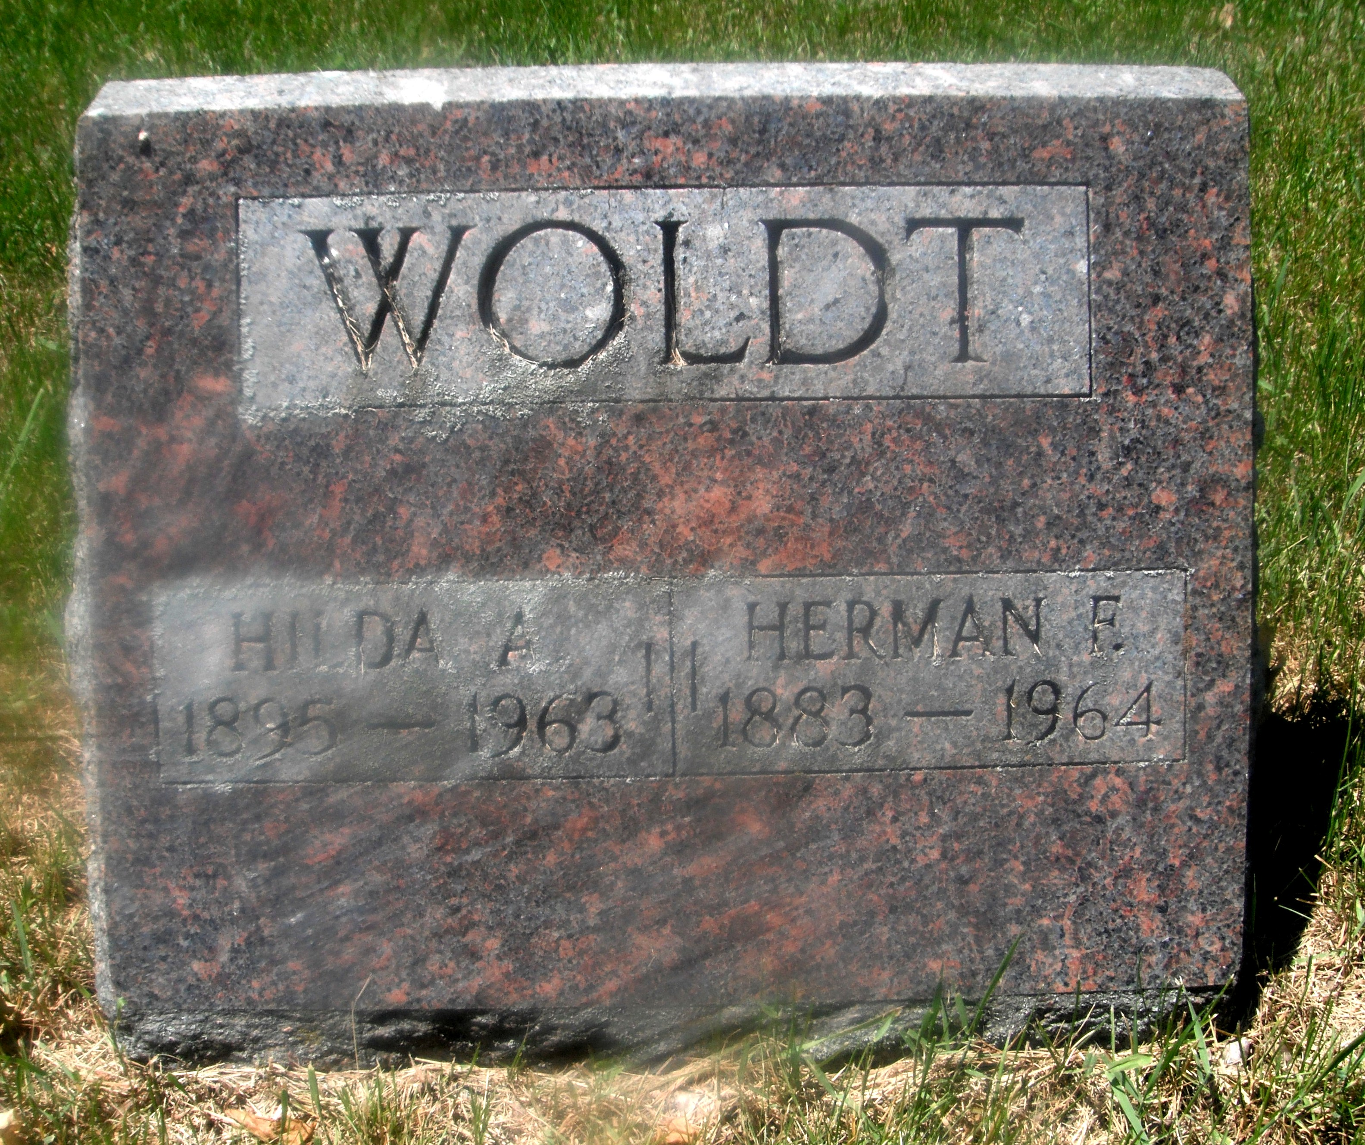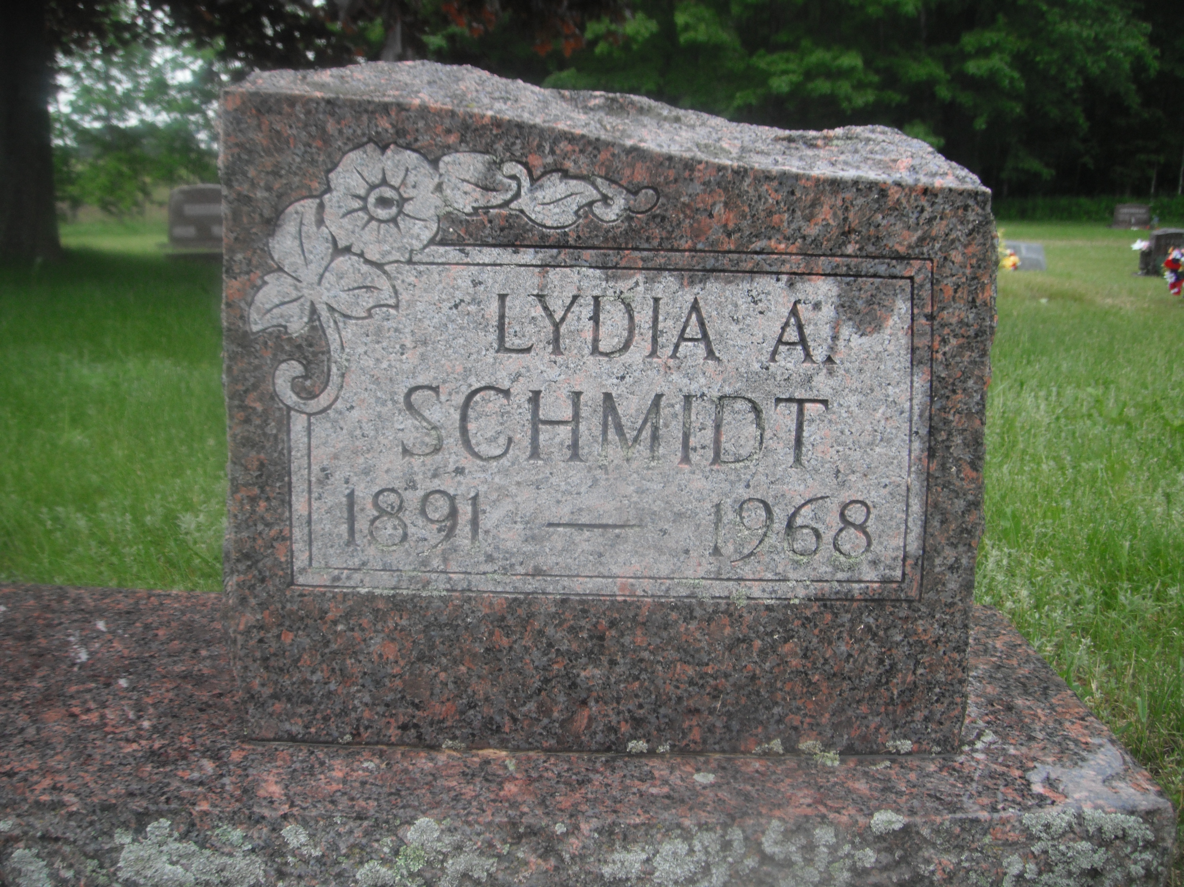
When the Methodist Church moved out of the log building south of the Woldt’ farm in 1911, August and Bertha rented the vacated church for their youngest son August “Dick” Woldt and wife Anna (Herbst). It was in that log home that three of their five children, Clara (Becker), Elizabeth “Betty” Bastar, and Roy Julius “Decker” Woldt were born. Myrtle (Woldt) Patza was born in the Cupola House in Egg Harbor and my father, Roland August “Fritz” Woldt was born in a backroom of the Sunrise Bar in Jacksonport.
The Woldt’ family tree got kick started in the U.S. when Minnie Lautenbach the daughter of Gustav Lautenbach married Nicholas Herbst the son of Valentine Herbst. Minnie’s in the picture below with my father, Roland “Fritz” Woldt in the back left and Minnie’s son Ernest or Harold in the back right. Nick, Minnie, Ernest and Harold share a headstone next to Valentine in the Zion Lutheran Cemetery.
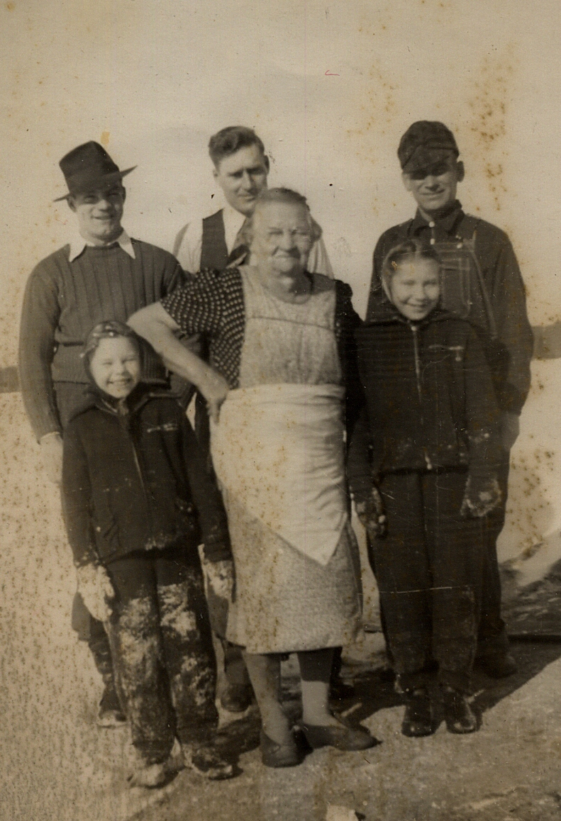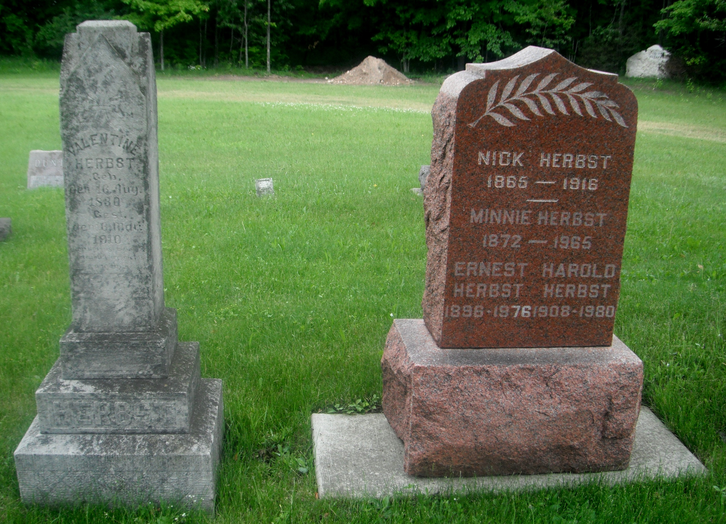
Stories of begetting and who’s related to whom abound, leading my father “Fritz” to often say, “Son, if you want a woman you’re not related to you’d better go south of the bridge in Sturgeon Bay.”
Woldt family roots were primarily planted in Egg Harbor, West Jacksonport, and Baileys Harbor, with branches reaching into every corner and across every bar in the County. Casey’ Inn was Uncle Casey, Paul’s Glass Bar in Bailey’s Harbor was Uncle Paul, Sister Bay Bowl was cousin Earl, C&C Club in Fish Creek was cousin Virginia Woldt Weisgerber, Herman Woldt’s daughter, cousin Ruthie owned Bley’s Bar in West Jacksonport as cousin Mike Lautenbach owns Mike’s Port Pub in Jacksonport and Otto Woldt’s great grandson Mike Woldt owns the current Woldt’s Corner at the corner of Co. S and Hwy 42/57. Oh Yes, although Lena of Lena’s Sip and Chat in Egg Harbor denied being related; she’d say “You damn fool, I’m not a relative,” she was in fact the sister to Viola Herbst Uncle Paul’s wife. And that’s just the tip of the stir stick.
FYI: To help sort out some of this it may help to know that Otto Woldt had four children, two boys Alvin and Lawrence and two girls Eva Jane Woldt Storm and Ellen. Alvin moved west to work on the railroads in Oregon and Washington and Lawrence moved to Green Bay to work in the meat packing industry. Mike Woldt, owner and “Woldt’s Corners” is a descendent of Otto Woldt. Herman Woldt’s wife was the sister of Earl Williams mother who was an Olson.
In the 20’s and 30’s Herman Woldt owned the bar and stagecoach stop in downtown Egg Harbor where my grandmother worked cleaning rooms. She often told of boiling sheets in lye the day before the stagecoach was due in town. A barn, now gone, behind the bar was used to care for the horses of patrons and stagecoach line. Fresh horses were used for the trip to northern Door County.
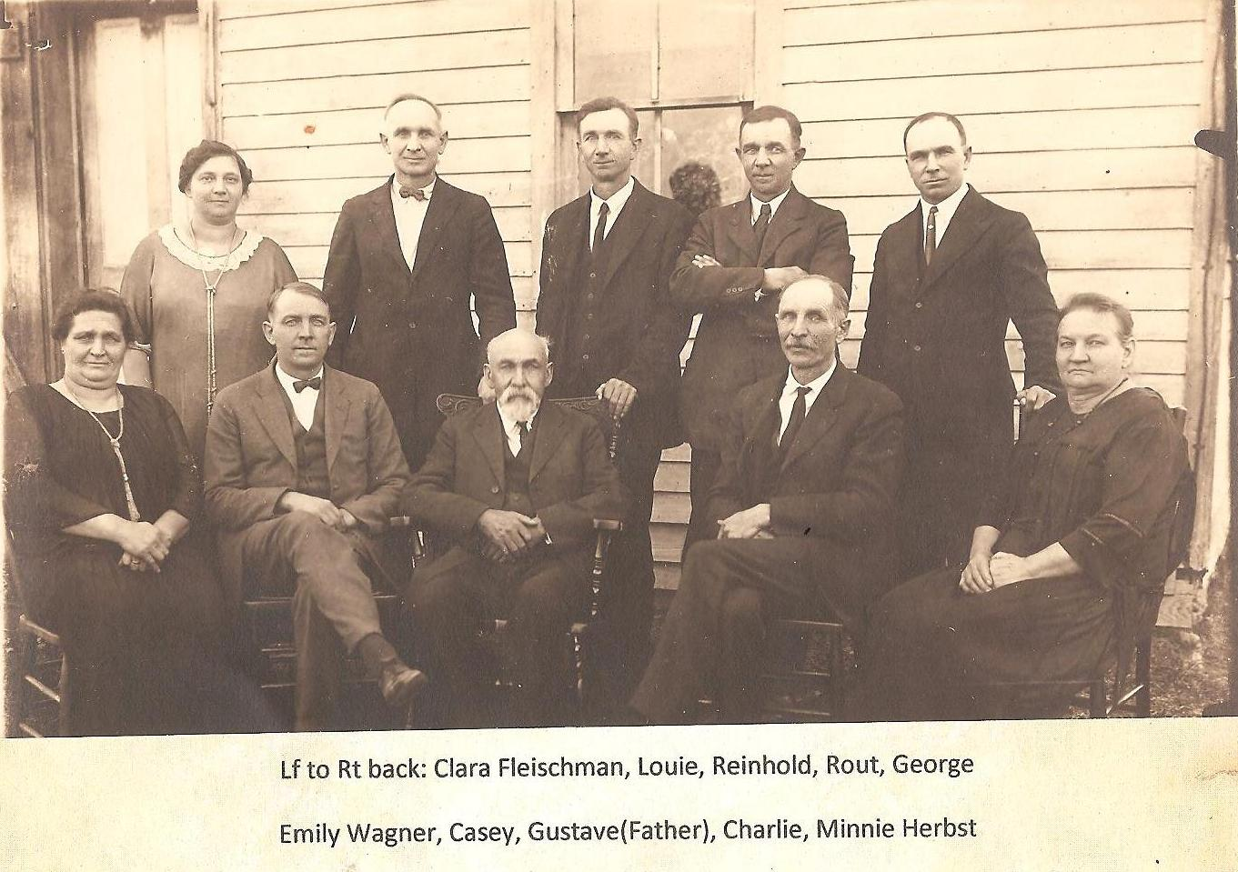
“Minnie” the daughter of Gustav Lautenbach had six brothers: Casey, Reinhold, Rout, Louie, Charlie, and George Lautenbach and two sisters: Clara (Lautenbach) Fleischman, daughter and Emily (Lautenbach) Wagner. Minnie married Nick Herbst son of Valentine and her brother Rout married Emma Woldt the seven month old daughter of August and Bertha when they arrived in Egg Harbor in October of 1881.
To introduce new blood to Egg Harbor, Fritz Woldt married Corrine Schneider the daughter of Emil and Christina who’d moved in two farms south east of the Woldt farm with most of their 14 kids, a few cows, one bull, a team of horses, 40 chickens, 7 pigs, 3 cats, a dog, and more ornery goats.
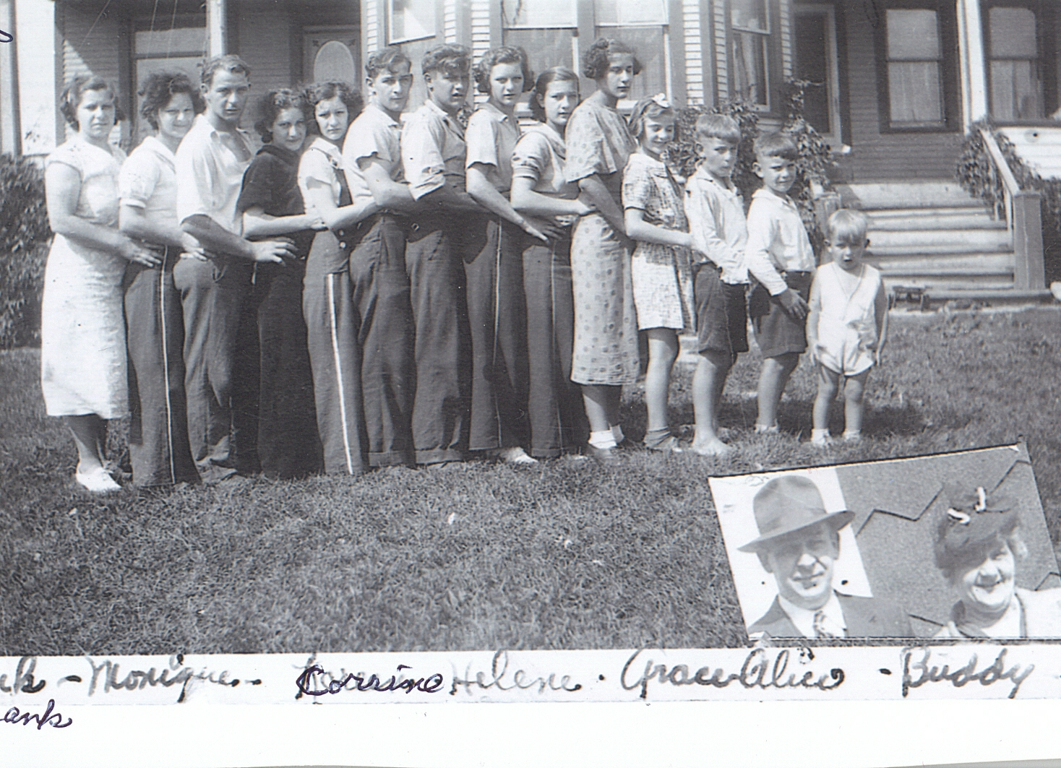
The Schneider family mark on Egg Harbor’ include Frank Schneider owning the original small grocery in the 70’s Joe building the Melody restaurant in the 60’s and my parents Corrine and Fritz Woldt building and running the Lull-Abi-Motel from 1955 to 1975. Family records from the 50’s and 60’s indicate bread at Schneider’s store never sold for more than a buck, a hamburger at Joe’s Melody restaurant sold with fries for fifty cents, and two could stay at the Lull-Abi Motel for $6 a night.
Woldt’ family gathering were frequent and fun! 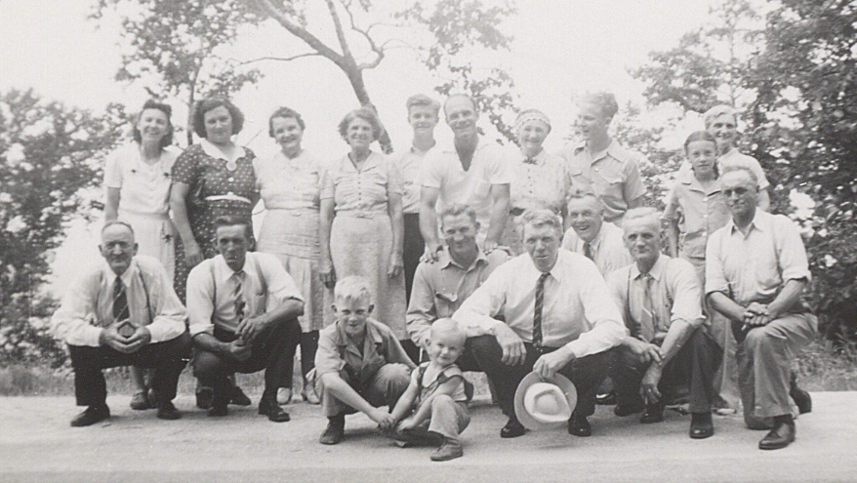
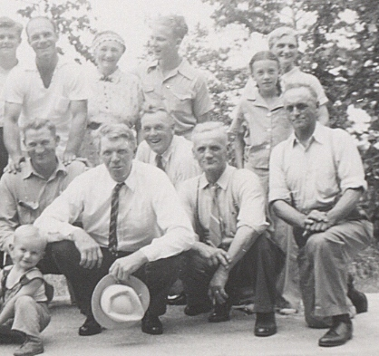
That’s Nick Schmidt “Uncle Doc” holding the hat with August “Dick” Woldt i.e. grandpa Dick over his shoulder, Otto Woldt next to him and Julius Woldt kneeling on one knee. Roy Julius “Decker” Woldt is in standing with his hands on the shoulders of a friend and Lida Woldt is standing in the back corner behind Gloria Patza daughter of Myrtle Woldt and Ben Patza.
August, Bertha, sons and daughters worked the family homestead in summer and found work in the logging camps in the winter. My grandfather August Junior was known as “Dick Woldt” or for me “Grandpa Dick.” Many think his name was Richard or he picked up the name because of his family genes. Neither was the case. You see, the enforcer in the logging camps was called “The Dick” and Grandpa Dick was known for his willingness to keep law and order in the camps. Herman had a similar reputation when he owned the bar/dance hall in downtown Egg Harbor in the 1920’s and the original Woldt’s Corners south of Sturgeon Bay (Corner of County O and Hwy #42) in the 1930’s. The original Woldt’s Corner is the one with the full size windmill and bandstand built on the north end of the building. During World War I Herman and Grandpa Dick both worked as lumber jacks. Farming and lumbering were considered an essential occupation and exempted them from having to fight in the war. Julius, along with his first wife “Anna” stayed on the farm with his parents and eventually inherited the homestead when Bertha died in 1921 and August Sr. moved in with Herman and his wife Hilda above the dance hall in downtown Egg Harbor. August Sr. died in while living with Herman and Hilda 1925. My uncle Roy Julius “Decker” Woldt than six years old remembers his cousin Ruby taking his hand and making him go upstairs to say good-by. Per Decker, you don’t forget something like that. In those days they didn’t embalm so he was just lying there in bed. Decker told me, “I’ll never forget looking down at him with his full head of gray hair and his long fluffy gray beard.”

Egg Harbor memories 1818 – 1968: Fritz and Corrine built the Lull Abi in 1955. Unit 2 and 4 rented for $8 for two and $10 for four. Per Shirley, grandma Hembel use to soak sheets in lye when getting ready for the next stagecoach.
August and Bertha’s daughter Emma Woldt married Gustav’s son Rout Minnienear Bley’s bar the Zion Lutheran church being organized in West Jacksonport by Gustav Lautenbach. In their buckboard was baby Emma less than a year old and following on horseback tied to the buckboard was their five year old son Otto. All had left Pomerania, Germany a month or two earlier looking for adventure and a new home in Wisconsin. While August purchased the land to farm, much of the first few years were spent lumbering off the maple trees for barn lumber and for fire wood they sold to steamers traveling around Deaths Door to and from Green Bay. Most of the Woldt men worked in the lumber camps receiving 50 cents a full cord of cut wood or selling it for two dollars a cord to steamship captains moored at the Egg Harbor dock. The Woldt’ farm was just north of what’s now Co. T and Maple Tree Road; up the road a piece from the log house on the corner which was at the time owned by members of the Zion Lutheran Church. August Woldt eventually rented the church building as a residence for his family in 1911 when the Gustav Lautenbach and his Zion Lutherans built their present church three miles south on “T” to be closer to their congregation at Bleys’ bar. At least that’s the way it was told to me. It was in that log building that August and Bertha raised Otto, Emma, Lidia, Herman, Julius, and my Grandfather August “Dick” Woldt.
When I was born, we were living in a rented house right next to Grandpa Woldt's house.

In the 1920’s Herman became very sick and had to go to Florida to recover. He had a flat-bed truck that he made into a "RV Camper". He built a house on top of the flat-bed and put a bed inside. He put in all the living essentials including a cookstove for his family to live in while in Florida. During that time Grandpa Dick (August Junior) and Grandma (Anna Herbst/Woldt/Hemble) move into town from the log cabin on the Woldt’ farm and ran the tavern and dance hall until Herman returned from Florida. When Herman returned to Egg Harbor, August and Anna moved a block away to rent a place above the barber shop in Egg Harbor which was at the top of the hill up from the Egg Harbor dock. A short time later August and Anna purchased their own tavern in Bailey’s Harbor and Herman and Hilda sold their downtown Egg Harbor bar and dance hall and bought a tavern 5 miles south of Sturgeon Bay on Hwy 42/57. Herman named it "Woldt's Corner".

FYI: August and Anna’s tavern in Bailey's Harbor was right down town on the water side on Hwy 57. The tavern didn't have living quarters so they rented the living quarters in the back half of the building across the street. John Brann owned the building and made coffins and furniture in the front half of the building. The building is still standing today. Across the front of the building is a big covered front porch. Back then, there were coffins stacked clear up to the ceiling all across the front porch. That building has changed hands many times through the years and eventually was converted to a tavern. Years later Anna’s brother, Paul Herbst, bought the tavern on the corner, named it "Paul's Glass Bar" and raised his family there. It later was called "Corner Bar" before it was purchased by Richard “Richie” Weisgerber and became “Weisgerber" Richie is the son of Green Bay packer Richard “Dick” Weisgerber who married Virginia Woldt daughter of Herman and Hilda. That’s what you call keeping the bars in Bailey’s and Egg Harbor as well as Fish Creek in the family. Dick Weisgerber owned the C&C Club for years where Herman tended bar until he died in 1964. Speaking of relative owning all the bars in the county, Casey’s in Egg Harbor was Anna’s brother. I use to go in to Lina’s Sip and Chat and say “Lina we’re related. She’d say “You G-damn fool, we’re not related” and I’d say, “who’s your sister?” and she’d say “Viola” and I’d say, “Who’s your sister married to?” and she’d say, “Paul Herbst you’re Grandma’s brother.

All of us kids went to the two room school house there in Bailey's Harbor. The hill next to the school was a perfect hill for all the neighborhood kids and their sleds. The only problem was that at the end of the hill was highway 57 and across the highway was a large barn next to the Florians Tavern. (At this time, there were no paved roads and many people still road their horses and wagons to town. They had the barn next to the tavern for the patrons to put their horses while at the tavern. Back then Conjurske Florian owned it and it was called the Florian. It burned down and Florian rebuilt it and named it the Florian II Tavern. I think they renamed it Florian III when his son or grandson took it over a couple of years ago but I'm not real sure.) Back to my sled story: The kids had to bank a sharp turn just as they reached the bottom of the hill and continue the run down the middle of highway 57. They would station a lookout at the bottom of the hill to look for cars headed toward town. You could usually sit on the hill all day and count the cars that passed through town on two hands. On one of the runs, I missed my turn and ended up running into the side of one of the store fronts on the water side of the highway. When I hit the front of the building, one of the plate glass windows across the front of the store shattered. I was really in trouble when they came to the house and asked my mother to pay for the window. On one of the school days at noon (you see we got out for one hour at lunch because alot of kids had to walk a distance to get home to eat their lunch) one of Fritz's best friends and I decided to make a few runs down the hill before returning to school. We didn't have a lookout but thought it would be OK since it had been pretty quiet along the street that day. We would ride "piggy back" down the hill, with one guy lying down on the sled using his hands to stear the sled. The "piggy back" rider would push off and jump on the back of the sled drivers back and ride down the hill. When we reached the road and banked to continue down Hwy 57, we were staring into the headlights of a Model T Ford. We just ducked our heads and slid right under the car as it traveled on it's way. We were lucky that those old cars stood so high off the ground or we would have been in real trouble.
Prohibition took place from 1922 to 1933. My Dad bought his beer from the Chicago bootleggers but it was too expensive to buy their hard liquor so my mother made "bath tub gin" at home for sale in the tavern that my dad owned in Bailey's Harbor. She would bottle up the booze and pack it into a large laundry basket and cover the bottles with food and loaves of bread to take it down the street to the tavern. My sister Clara and I would dance the Charleston in the tavern to the music playing on the Nickelodeon. When we finished dancing, the customers would throw coins on the floor for our tip. Sometimes my dad would sit up a "boxing ring" with bar stools in the middle of the floor and have Fritz and I box three minute rounds to entertain the customers. Dad just loved Jack Dempsy and had real boxing gloves for us boys to wear. Fritz was older and stronger and usually could whip me good. But, one time he made me mad and I really slugged him hard in the nose. To the patrons delight, I gave Fritz's a bloody nose. He never let me forget it through the years.

Around 1924 or 1925 we moved down the street a block or so to a building that is still standing on the water side of Hwy 57. My mother opened a restaurant called the "Green Haven Restaurant". There was living quarters in the back and rooms upstairs for the kids to sleep. My dad continued to run his Tavern down the street while mother ran the restaurant. Clara helped mother serve in the restaurant. Myrtle was working as a waitress at Maxwelton Brea Resort. My mom and dad started fighting alot because of my dad's drinking. The were long periods that he was drinking so heavily that he couldn't open the tavern and it remained closed for days at a time. He had started drinking so heavily that he had to be sent to Green Bay to "dry out".

Things got so bad that my mother left my dad and moved to Sturgeon Bay to work in the Carmen Hotel. Fritz went to live with Uncle Doc and Aunt Lydia Schmidt, I think Clara stayed to help my dad out, and Betty, mother and I moved into the Carmen Hotel. The owner of the hotel didn't like that mother had two kids living with her in the room that she was renting at the hotel. I was sent to live with Uncle Herman and Aunt Hilda at Woldt's Corner Tavern and Dancehall south of Sturgeon Bay. They lived above the tavern and you could hear the glasses clinking, voices, and music through the floor at night until closing time after midnight. There were mornings that I would get up before the crack of dawn and go down stairs to wash dirty bar glasses before I headed to school. I attended the little Stokes School across the road from the tavern during my 7th and 8th grades. Uncle Herman's daughter Ruby drove us kids to school in Sturgeon Bay when I was in the 9th and 10th grade.

After the Carmen Hotel was sold in 1934, my mother and her sister-in-law Louise Herbst opened a cafe on the west side of Sturgeon Bay. I moved back in with mother and Betty in a one bedroom apartment across the street from the cafe. The cafe is next to Curley's Cleaners in the block right before you get to the bridge. I finished my 11th and 12th grade years at Sturgeon Bay High School living with mother. I had to walk to school across the bridge between west Sturgeon Bay and east Sturgeon Bay. Some days the snow and wind were blowing so hard you could barely standup straight.

Some time along the way, my dad and mother were divorced. Mother and Frank Hembel were married in 1940 and for the first time in many years, she did not have to work outside the home. I joined the Air Force during World War II. While I was still in the war, I loaned mother and Frank the money for a down payment on the house they purchased at 303 W. Maple in Sturgeon Bay. They remodeled the upstairs into an apartment for Fritz's family and put in showers and sleeping quarters downstairs to house defense workers during the war years. Rene, Christine and Richard lived upstairs while Fritz was in the army during the war. In the most recent copy of the Door County magazine called the "Open Door", the 303 W. Maple house was listed as one of the top twenty historical houses in Sturgeon Bay.

PS ... if you would take the time to load your Family Tree Maker onto your computer and load the GEDCOM file I copied to your hard drive, you would have all the family information right at your fingertips .. it really is easy ... give it a try cuz ;~)

see you this summer
love and kisses to you and Emily
August, Bertha, Emma, Lidia, Herman, Julius, and August farmed the land
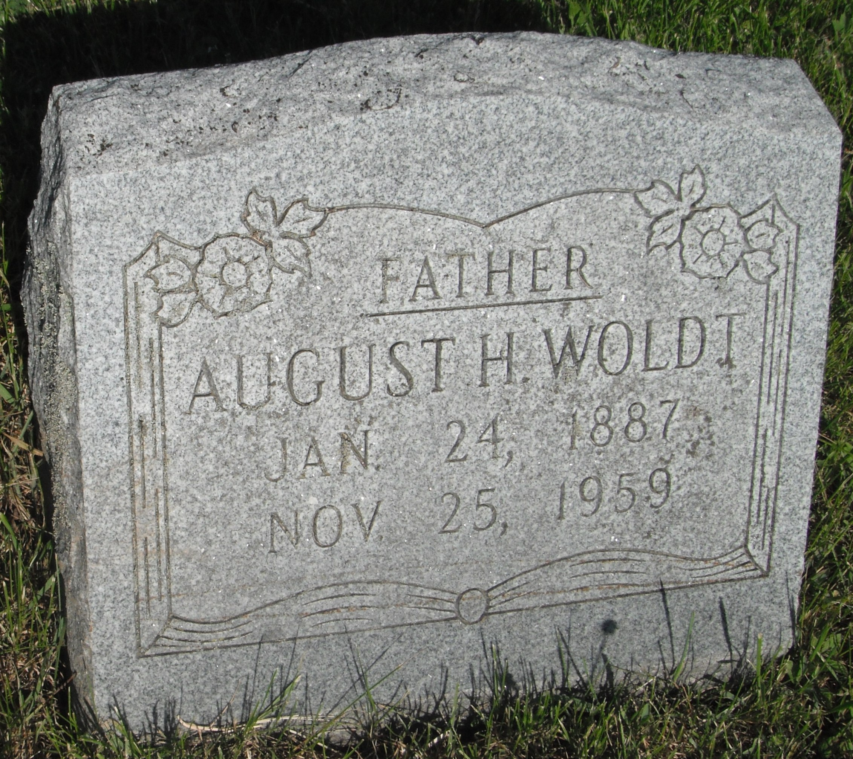
to either 1869 or 1871 depending on whether Charles son of August and Bertha was born in Egg Harbor or was one year old when they arrived in the U.S. from Germany. August would have been 17 and Bertha 19. Stories tell of them being very young. At any rate, August would have been 18 and Bertha 20 when Charles was born in 1870.
Family stories told by my uncle Roy “Decker” Woldt tell of August and Bertha’s children (Otto, Julius, Herman (1883-1964), August (1887-1959), and Lidia) all being born on the Woldt farm just east of town and up the hill from the house on the corner of which was the Methodist Church up until it was sold in 1911. It’s believed the church was sold to the Woldt’s in 1911 and was used as a residence by August and Anna until their divorce at which time Dad “Fritz” went to live with his aunt Lidia (Woldt) Schmidt and Roy “Deck” Woldt went to live with his Uncle Herman and aunt Hilda.
So let’s start The 1910 census has them all living on the summer of generations the summer of 1885 when August Woldt (1852 – 1925)landed at Ellis Island from Germany with wife Bertha (1850 – 1921)and found their way to Wisconsin via the railroad, stagecoach, and buckboard eventually settling on farmland just east of town and north or a small rural Lutheran Church. Rumor has it they set their GPS to and talked the preacher out of land north of the church on which they raised five sons; Charles . Otto, Julius, Herman, and my Grandfather August Eventually, they purchased the church in 1911 because that’s where
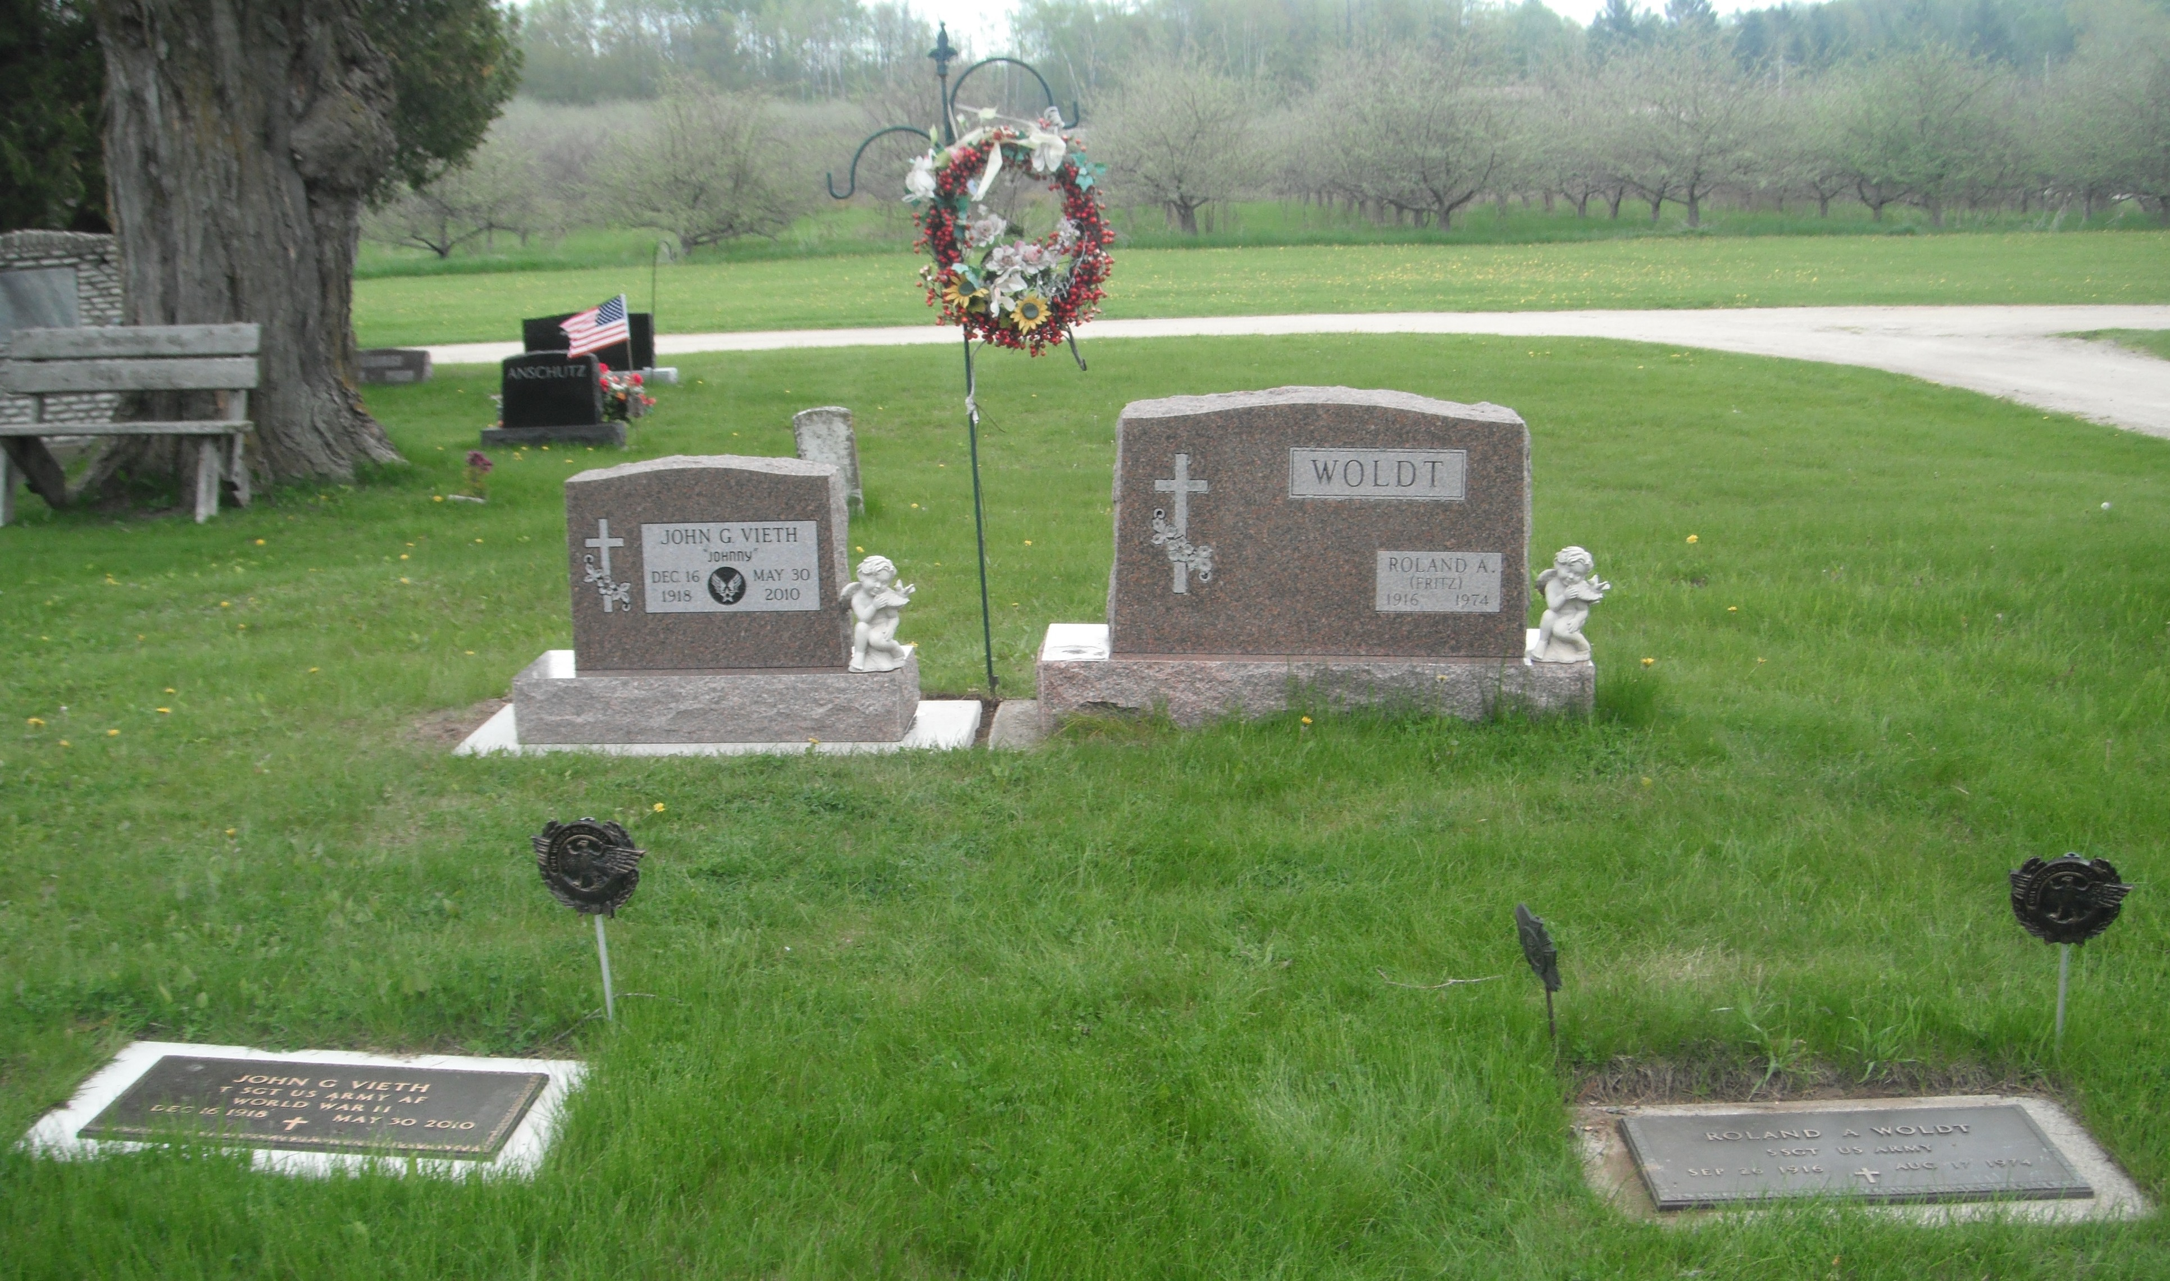
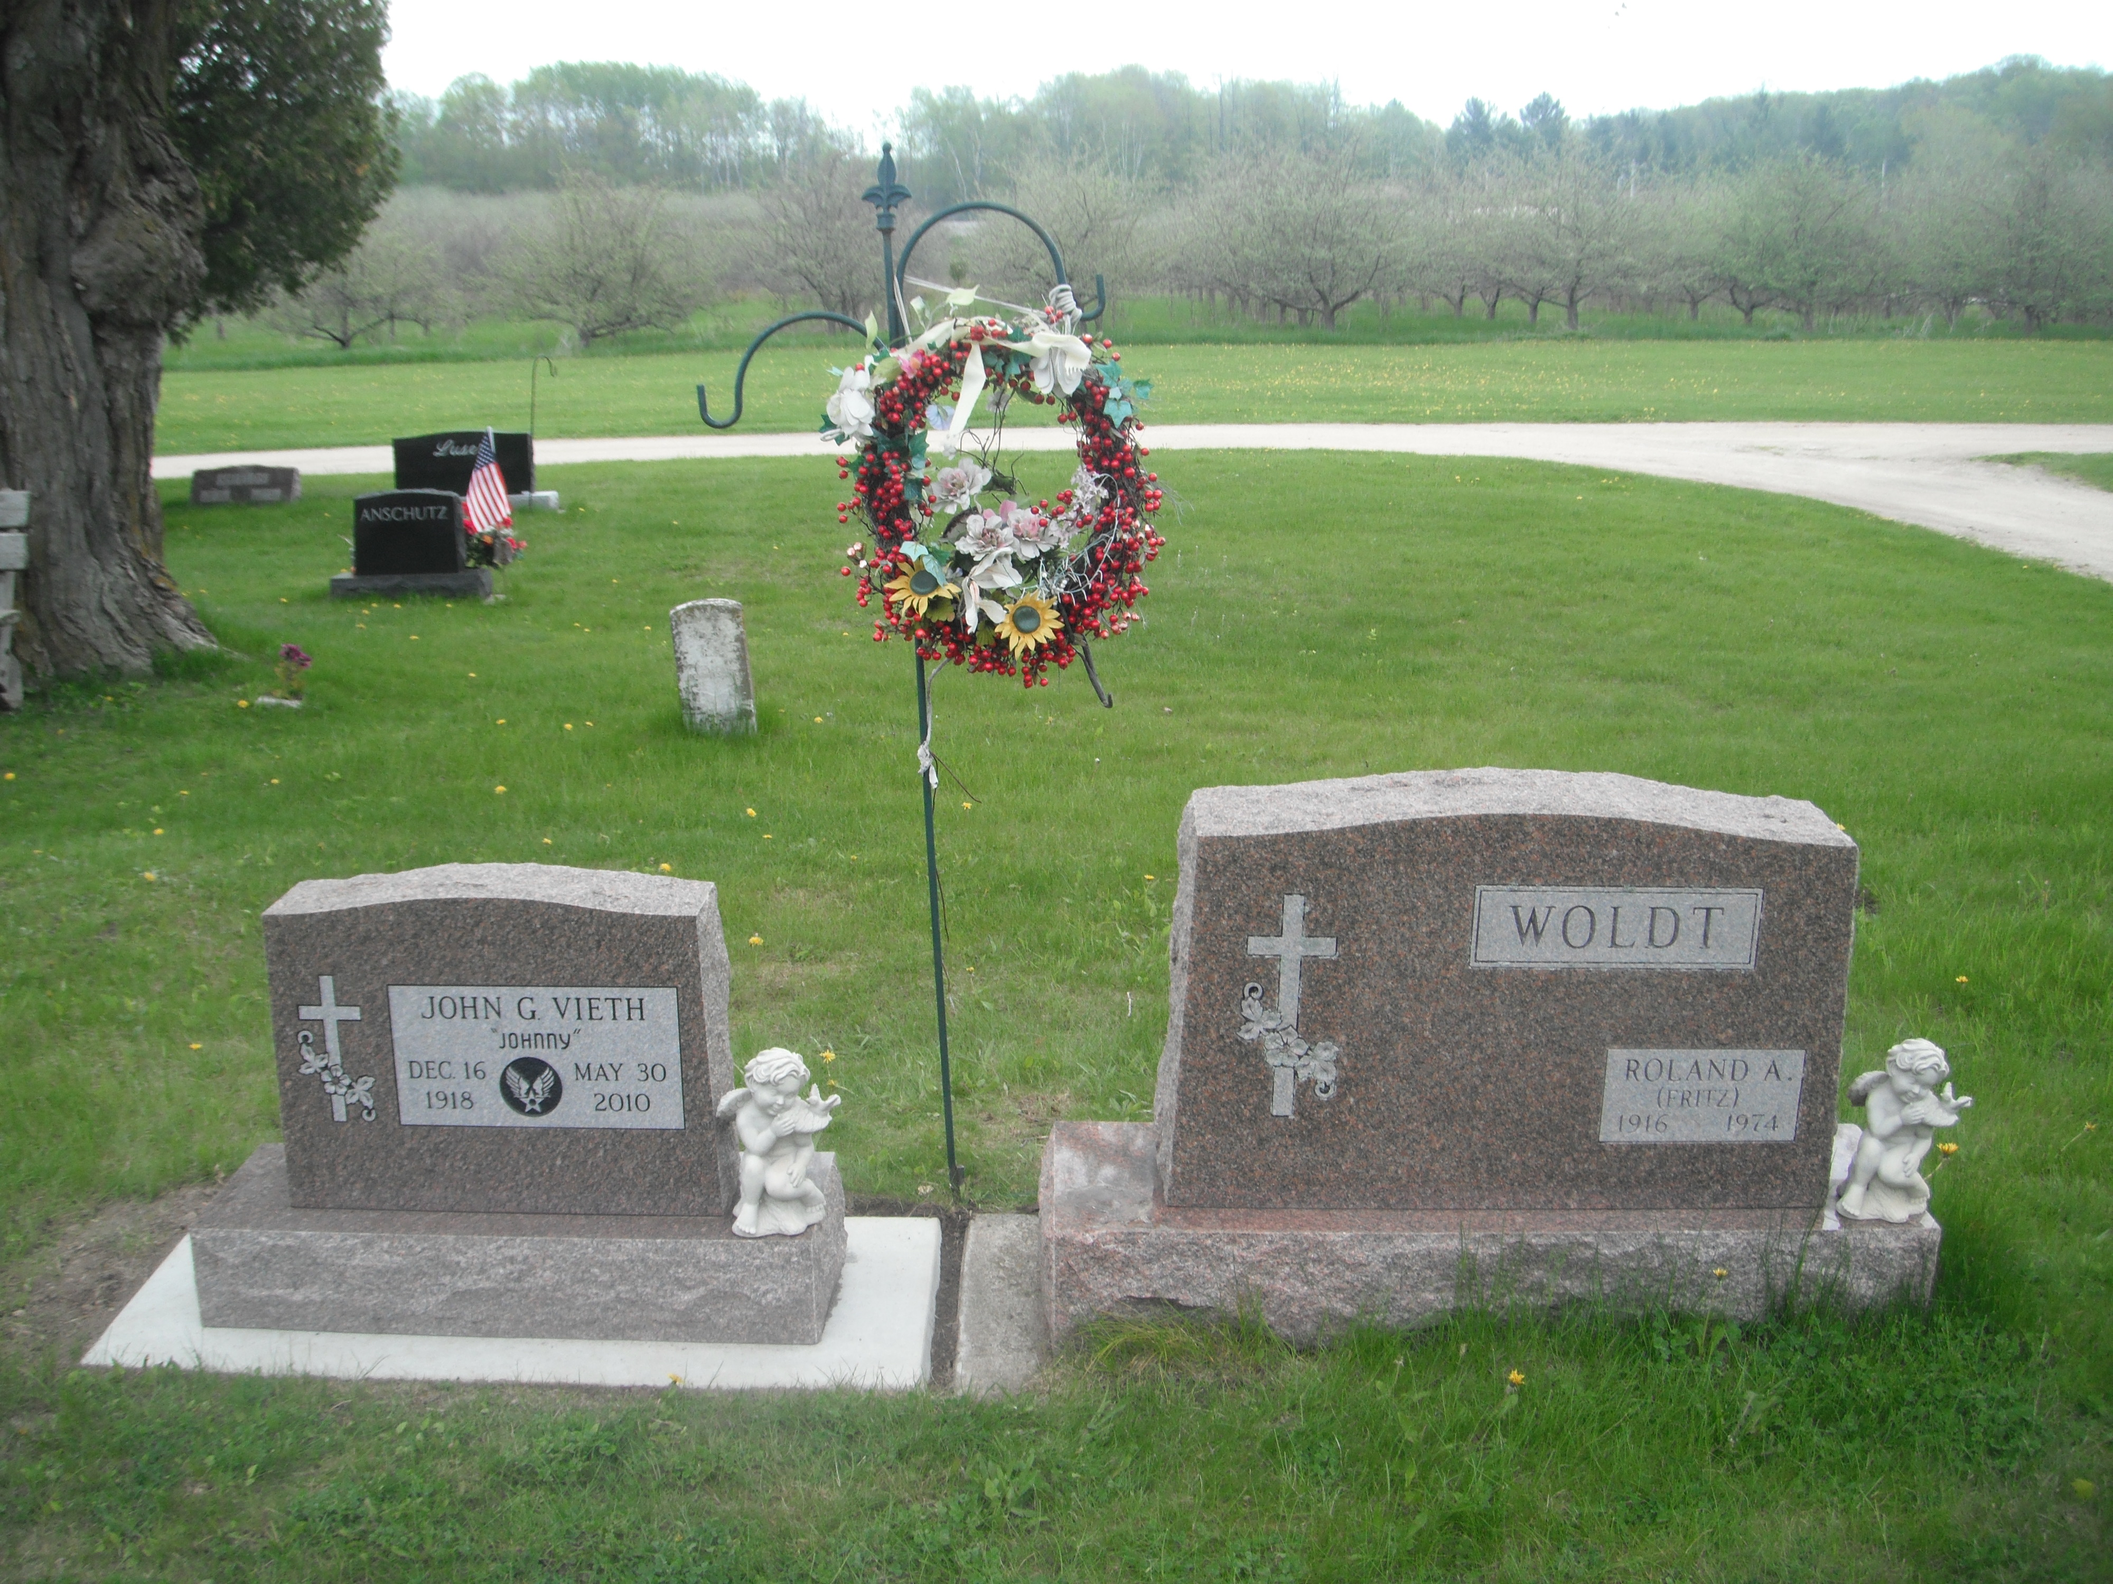
The 1910 census includes: Address; name; relationship to family head; sex; race; age; marital status; number of years of present marriage; for women, number of children born and number now living; birthplace; and mother tongue of person and parents; if foreign born, year of immigration, whether naturalized and whether able to speak English, or if not, language spoken; occupation, industry, and class of worker. There are additional categories that are listed that I did not include in the information listed below.

Thirteenth Census of the United States: 1910 Population
State of Wisconsin
County of Door
Township or Other Division of County: Egg Harbor Town
Enumeration District No 44 Wheet No 6
Enumerated on 22nd day of April 1910, Joseph Schneider Enumerator:
Number 13 dwelling # 54
Woldt, August Head MW 59 Married 39 yrs Ger. Fa: Ger. Mo: Ger. Naturalized 1885 Farmer Own Farm
Woldt, Bertha wife FW 60 M 39 yrs child 8/8 born-German Fa: Ger. Mo: Ger. Nat in 1885 no occup
Woldt, Herman son MW 26 Single born-Wisconsin Fa: Ger. Mo. Ger. Bar Keeper / Saloon
Woldt, Julius son MW 24 Single born-Wisconsin Fa: Ger. Mo: Ger Farmer / Home Farm
Woldt, August son MW 22 Single born-Wisconsin Fa: Ger. Mo: Ger. Farmer / Home Farm
Woldt, Emma daughter FW 28 Single born-Germany Fa: Ger. Mo: Ger. Naturalized 1885 no occupation
Woldt, Lydia daughter FW 19 Single born-Wisconsin Fa: Ger. Mo: Ger. working / hotel

Notes from Sandy
August Woldt left his farm to his son Julius Woldt and moved in with his son Herman Wordt and family.
He was living with his son Herman at the time of his death in 1925

As you can see, August, Bertha and Emma were all born in Germany (as was Otto - 1876) and were naturalized citizen in the year 1885. Emma was 28 on the census for 1910 so when was born sometime in 1881. On the 1920 census they list that they immigrated from Pomerania in 1881 so Emma must have been an infant when she arrive in the US. Herman was the next child born in 1883 in Judville WI.

My own memories of Egg Harbor date back to July of ’44 nine months prior to my birth April 21, 1945. What I couldn’t hear clearly those first nine months was retold first by my mom and sister Christine and then verified by neighbors and my dad’s army buddies. Summer and fall of ’44 through apple season at Horseshoe Bay went well. Mom and dad had moved from Sturgeon Bay to one of the three small cottages near the apple barns on top the bluff at Horseshoe Bay Farm south of Egg Harbor. The way I got it figured, I got a foot hold sometime in July of ’44 and had a comfortable ride through the summer and into the fall until the apples were picked and dad spent most of his workday grading apples for Al Erickson the then manager of Horseshoe Bay Farms. That is until Erickson decided to test the medal of my ole man by kicking over a pail of apples and warning Dad and his buddy to either pick-em-up
Mom and dad built the Lull Abi motel in July 2, 1955. Uncle Joe built the Melody Resturant in 1957.
The rate of a room at the Lull abi in ’55 was $8 for 2 or $10 for four up until 10 P.m.then it dropped to $6 for 2 and $8 for four.
Mom said she married Fritz in 1940, Chris was born in “42 and they lived on the Schmidt farm until they moved to Horseshoe bay in 1944 when Chris was 2 and ½ not quite 3. So it could have been in the spring of 1944. So dad only worked there until let’s see, mom got pregnant with me in July of 44 so he must have punched out Al Erickson in maybe June as two weeks later he was drafted and spent one more night in Egg Harbor with the women per Shorty Hain the night before they left on the train. Mom remembers standing with Chris in front of Birnchines garage waiting for the bus when Dad left for the army so it must have been in spring of 45 as they held the ship until they knew I was OK.
Let’s see? If they held the ship on April 21, 1945 and nine months earlier they spent one more night in Egg Harbor or around July 21, 1944, it stands to reason Dad punched out Al Erickson in May or June 1944 shortly after they moved to Horseshoe Bay farms when Chris was less then 3 years old. Chris was born November 12, 1942 so would have been 2 on November 12, 1944 and 2 ½ on April 21, 1945 when I was born. Odds are it was the fall of 1944 Niemier picked them up and Dad and buddy. Apple season 1944 all through and were grading apples. Patza’s lived there too. Down below and we lived up on the hill. You kicked them over delibertly and Al said he did and Dad walked off. Moved up there in summer of 44 or it could have been spring. Opening of the orchards rather than work in the ship yard. Have the picture when Mom won award for how to run the ship yard after the war.
Herman’s wife Hilda was an Olson. She was a sister to Earl’s mother and that’s how Virgina Weisgerber was a cousin to Earl. Otto Woldt had four kids 2 boys Alvin and Lawerence and Evajane who’s picture Deck carried while in the service she married a Storm who French kissed A. Eloise and the other daughter was Ellen. Herman convinced Louie Williams Earl’s father to buy the Rock where Deck tended bar for a summer and later to buy the Sister Bay Bowl.
XXXXXXXXXXXXXX On fourth of march real cold six weeks before I was born, pitch dark, Grandma Shnieder came up, Chris and mom sat and watched as dad and his buddy was picked up by the bus.
As apples came down ramp Al kicked them over and said pick them up. Dad sad why. Al said if you don’t I’m the boss and you’ll be in the service by the end of the month. Dad refused and six weeks before I was born he was picked up in Egg Har bor.
Richard, I almost forgot, there was also a four year old daughter on the ship log named Anna who was with August and Bertha Woldt.
In checking the ship logs on Castle Garden immigrantion arrivals, August Woldt (age 29), Bertha (age 30), Carl (age 9) Emma (age 7 months) and Otto (age 6) arrived on October 22, 1881 aboard the ship Leipzig, sailing from the port of Bremen Germany (Prussia). Since the date is 1881, that would mean that the child "Carl" is Charles. I was suspecious about Charles being born in Egg Harbor. Frequently, on the death certificates, information is being given by a family member that is guessing what the answer is without really knowing for sure. Hopes this helps with your research.

your cuz sandy

The 1910 census includes: Address; name; relationship to family head; sex; race; age; marital status; number of years of present marriage; for women, number of children born and number now living; birthplace; and mother tongue of person and parents; if foreign born, year of immigration, whether naturalized and whether able to speak English, or if not, language spoken; occupation, industry, and class of worker. There are additional categories not include in the information below. (Insert web address for census)
From Lisa Bley Bieri December 2012. Sent to me after the campaign.
Rich: We are related via the Herbst family. I think my grandmother Lydia Herbst Bley was your grandmother Anna's sister. Aunt Annie gave me a fish bowl, " to remember her by" when I was a little girl; I still have it. Her mother Minnie bought a pump organ for Anna to play when she was a little girl, it made the rounds and ended up in another sister's house in Munising, Michigan. In 1991 it was headed for the junk yard after her death. I rescued it back to Jacksonport where it started out. A really pretty piece and lots of history.

So there, a little history because I LOVE family history and making connections.

Lisa
Sent from my iPad

